



TAZAMA RULE STUDIO (TRS)
USER MANUAL

Version 0.1
06.03.2026
Document Information
Project | TAZAMA FRMS
Document Title | TAZAMA RULE STUDIO (TRS)
Prepared by | BEHJET ANSARI – SENIOR BA @ PAYSYSLABS
Version Number | 0.1
Version Date | 06.03.2026

Document Revision History
Date | Author | Version | Change Reference
06.03.2026 | BEHJET ANSARI | 0.1 | BASELINE VERSION SHARED WITH TAZAMA FOR REVIEW

Table of Contents
1. Getting Started with TRS 7
1.1. What is TRS? 7
1.2. Who Should Read This? 7
2. Who Does What? Roles & Governance 8
2.1. Understanding the Three Roles 8
1. Maker 8
2. Checker 8
3. Deployer 9
3. How a Rule Gets Built & Deployed 10
3.1. The Big Picture 10
3.2. Your End-to-End Journey 10
Step 1 - Maker: Login 10
Step 2 - Maker: Enter Basic Details in Rule Overview 10
Step 3 - Maker: Build Rule and Test Cases 10
Step 4 - Maker: Sync and Deploy Files 11
Step 5 - Maker: Run Simulations and Validate 11
Step 6 - Maker: Send for Approval 11
Step 7 - Checker: Review Rule and Run Simulation 11
Step 8 - Checker: Approve the Configuration 11
Step 9 - Deployer: Deploy Configuration to Target Environment 11
3.3. See It at a Glance 12
3.4. Quick Reference 12
4. Logging In 14
1. Keeping Your Session Secure 14
5. Your Rule Dashboard 15
5.1. Finding the Rule You Need 15
5.2. Understanding Rule Statuses 16
5.3. What Can You Do with a Rule? 16
6. Setting Up Your Rule 17
6.1. Step 1: Give Your Rule an Identity 17
1. Choosing the Right Configuration 17
2. Filling in the Rule Details 18
3. Ready to Move On? 19
6.2. Step 2: Know Your Data 19
1. Metadata 20
2. DataCache 21
3. Network Map 21
4. Transaction Payload 21
7. Building Your Rule 22
7.1. How the Canvas Works 23
7.2. What You Can Do 23
7.3. Node Reference 24
1. Main Canvas 24
2. Nested Canvas 28
7.4. Previewing the Generated Code 34
1. How Code Generation Works 34
2. Spotting Errors Before They Cause Problems 35
7.5. Viewing the JSON 36
7.6. Saving Your Work 37
7.7. When to Reset Canvas 37
8. Testing Your Rule 39
8.1. Why Test Your Rule? 39
8.2. Building Your Test Cases 39
8.3. Test Case Generator Nodes 40
1. Main Canvas 40
8.4. Previewing the Generated Test Code 43
1. How Code Generation Works 43
2. Spotting Errors Before They Cause Problems 44
8.5. Exporting as JSON 45
8.6. Saving Your Work 45
8.7. When to Reset 45
9. Running Your Simulations 46
9.1. Getting Ready to Simulate 47
9.2. Reading Your Test Report 47
9.3. Testing in Isolation: Rule-Only Mode 51
9.4. Testing End-to-End: DEMS-Driven Mode 51
10. Sending Your Rule for Approval 52
10.1. Are You Ready to Submit? 52
10.2. How to Submit 53
10.3. What Happens After You Submit 53
10.4. If Your Rule Gets Rejected 54
11. Reviewing a Rule as a Checker 54
11.1. Finding Rules to Review 54
11.2. What to Review 55
1. Rule Logic and Configuration 55
2. Test Cases and Coverage 55
3. Simulation Results 56
11.3. Aligning with Fraud Strategy 56
11.4. Making Your Decision 56
12. Approving the Rule 57
12.1. What Approval Does 57
13. Deploying to Production 58
13.1. Finding Approved Rules 58
13.2. Before You Deploy 58
13.3. How to Deploy 59
13.4. What If Something Goes Wrong? 59
14. Viewing Your Simulation Logs 60
15. Appendices 61
15.1. Closing Note 61
15.2. Support and Escalation 62
15.3. Glossary 62

Getting Started with TRS

What is TRS?
Welcome to the Tazama Rule Studio (TRS) module enables users to define, test, and simulate transaction rules within the Tazama ecosystem. It offers flexible rule creation and configuration, and supports testing rules in isolation or with customized transaction data through error handling. The module integrates test case creation and execution, ensuring that rules meet predefined conditions and regulatory standards. By allowing real-world validation and improving testing efficiency, TRS ensures that rules are thoroughly tested, accurate, and ready for deployment, ultimately enhancing the reliability and performance of the system.

Who Should Read This?
This manual is written for anyone who creates, reviews, or deploys rules within the Tazama ecosystem. If you fall into one of the categories below, this guide is for you:
- Makers — Rule creators responsible for building and testing rule logic.
- Checkers — Rule reviewers responsible for validating and approving rule configurations.
- Deployers — Technical operators responsible for publishing approved rules to production environments.
You’ll get the most out of TRS with a basic understanding of transaction monitoring and the Tazama platform. You don’t need to know how to code — but if you’re planning to use custom code nodes, some familiarity with JavaScript and TypeScript will come in handy.

Who Does What? Roles & Governance

Understanding the Three Roles
TRS is built around a Maker–Checker–Deployer governance model. This means no single person can create a rule and push it to production on their own — every rule goes through a structured chain of review and sign-off. Your role determines exactly what you can see and do within TRS.
Here’s how each role works:

Maker
As the rule author, the Maker spends most of their time in the Rule Builder designing logic and running simulations. Once the rule is ready, the Maker submits it for Checker review.
Responsibilities:
- Design rule logic using available nodes
- Define thresholds, variables, custom functions, and conditions
- Perform unit-level & system-level validation using the Simulation Sandbox
- Save rule drafts, or put rules on hold in case of a blocker
- Submit rules for approval
Restrictions
- Cannot approve own rules
- Cannot deploy rules to production
- Cannot modify rules once submitted for review (unless rejected)

Checker
As a Checker, your job is to cast a critical eye over everything the Maker has built. You review the rule logic, run your own simulations if needed, and either approve the rule for deployment or send it back with comments.
Responsibilities:
- Review rule logic and configuration
- Approve or reject rule submissions
- Provide comments in case of rejection
- Validate alignment with fraud strategy and risk appetite
- Assess potential false positive/false negative impact
Restrictions
- Cannot modify rule logic directly
- Cannot deploy rules

Deployer
Deployers are the final step in the chain. Once a rule is approved, you verify everything is in order and push it to the production environment.
Responsibilities:
- Verify approval status
- Execute deployment process
- Confirm successful activation of rule
- Monitor initial post-deployment execution status
Restrictions
- Cannot alter rule logic
- Cannot approve rules
- Cannot create new rules

How a Rule Gets Built & Deployed
Every rule in TRS follows the same journey - from the Maker’s first keystroke to a live deployment in production. This section walks you through that journey. The steps below describe the standard “happy path” involving three roles: Maker, Checker, and Deployer.

The Big Picture
A rule touches four environments on its way from idea to production: the TRS application itself, the GitHub Staging branch, the DEV branch, and finally the PROD branch. Each role only has access to the environments relevant to their responsibilities - the system enforces those boundaries automatically.

Your End-to-End Journey

Step 1 - Maker: Login
The Maker authenticates via the designated TRS URL using their assigned credentials. The system enforces Role-Based Access Control (RBAC) and establishes a secure, time-bound session upon successful login.

Step 2 - Maker: Enter Basic Details in Rule Overview
The Maker navigates to Step 1: Create New Rule and completes the foundational rule overview metadata. This includes selecting the Rule Configuration, providing a Rule Name and Version, setting the Rule Type (Fraud, AML, or Fraud & AML), writing a Description, and specifying the Transaction Type and its version.
Upon saving, the system validates all mandatory fields and the rule is created in In Progress status. GitHub automatically initiates a repository in the Staging branch to track the new rule.

Step 3 - Maker: Build Rule and Test Cases
Using the Rule Builder, the Maker constructs the rule logic visually by dragging and connecting nodes on the canvas. This includes defining variables, thresholds, conditions, custom functions, and execution flow. The Maker also creates corresponding test cases in the Test Case Builder to validate expected rule behavior across defined scenarios.
The Maker may use the Generate Code feature at any point to inspect the underlying TypeScript and resolve any syntax errors before proceeding.

Step 4 - Maker: Sync and Deploy Files
Once the rule and test cases are complete, the Maker clicks Sync to GitHub to commit all rule and test case files to GitHub, followed by Deploy Rule to push the configurations to the DEV branch, making the rule available for simulation execution.

Step 5 - Maker: Run Simulations and Validate
With the rule deployed to the DEV environment, the Maker runs one or both simulation modes to validate rule behavior:
- Rule-Only Simulation: Tests the rule in isolation using manually entered payload values to confirm logic correctness.
- DEMS-driven Simulation: Ingests a transaction through the DEMS ingestion service to validate end-to-end rule behavior in a realistic context.
The Maker reviews the Test Report and Result Payload to confirm all test cases pass and coverage is adequate. Once satisfied, the Maker proceeds to submit the rule for approval.

Step 6 - Maker: Send for Approval
The Maker submits the rule for review by clicking Send for Approval. The rule status transitions from In Progress to Under Review. The Maker can no longer modify the rule configuration at this point unless it is subsequently rejected by the Checker.

Step 7 - Checker: Review Rule and Run Simulation
The Checker logs in and locates the rule in Under Review status on the Homepage. The Checker inspects the rule logic, configuration parameters, and generated TypeScript code. The Checker may also independently run simulations to verify that the rule behaves as expected and aligns with the organization’s fraud strategy and risk appetite.

Step 8 - Checker: Approve the Configuration
On the happy path, the Checker is satisfied with the rule logic and approves the configuration. The rule status transitions to Approved. The rule is now locked from further modification and becomes available to the Deployer for production deployment.

Step 9 - Deployer: Deploy Configuration to Target Environment
The Deployer logs in and locates the rule in Approved status. After verifying the approval status and conducting any required pre-deployment checks, the Deployer initiates the deployment. The system promotes the rule configuration to the PROD branch in GitHub and activates the rule in the production environment.
The rule status transitions to Deployed. The rule is now live and operational in the production environment. The workflow is complete.

See It at a Glance
The diagram below shows the full happy path — how your rule flows from the Maker through review, approval, and into production.
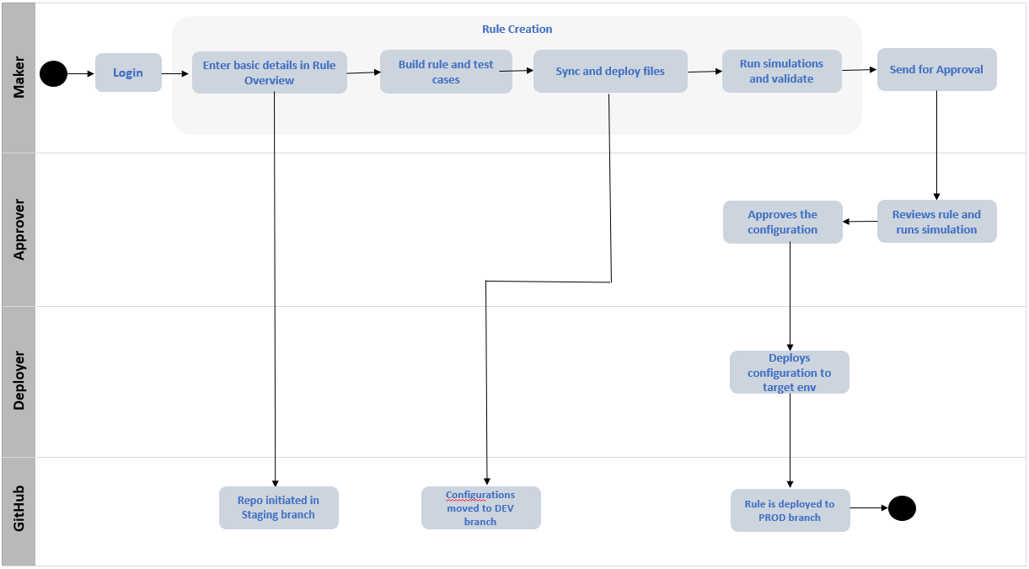Figure 1: Rule Creation to Deployment – Happy flow.

Quick Reference
Here’s the complete workflow at a glance — each step, who owns it, and where it leaves your rule.
Step | Role | Action | Resulting Status / State
1 | Maker | Logging In | Authenticated session established
2 | Maker | Enter basic details in Rule Overview | Rule created — In Progress; Staging branch initialised in GitHub
3 | Maker | Build rule and test cases | Rule logic and test cases defined — In Progress
4 | Maker | Sync and deploy files | Files committed and moved to DEV branch in GitHub
5 | Maker | Run simulations and validate | Rule validated — In Progress
6 | Maker | Send for Approval | Rule status — Under Review
7 | Checker | Review rule and run simulation | Rule remains Under Review
8 | Checker | Approve the configuration | Rule status — Approved
9 | Deployer | Deploy configuration to target environment | Rule promoted to PROD branch — Deployed

Logging In
To get started, navigate to your organization’s TRS URL and log in with the credentials you’ve been assigned. Access is restricted to authorized users — if you haven’t been set up yet, contact your system administrator.
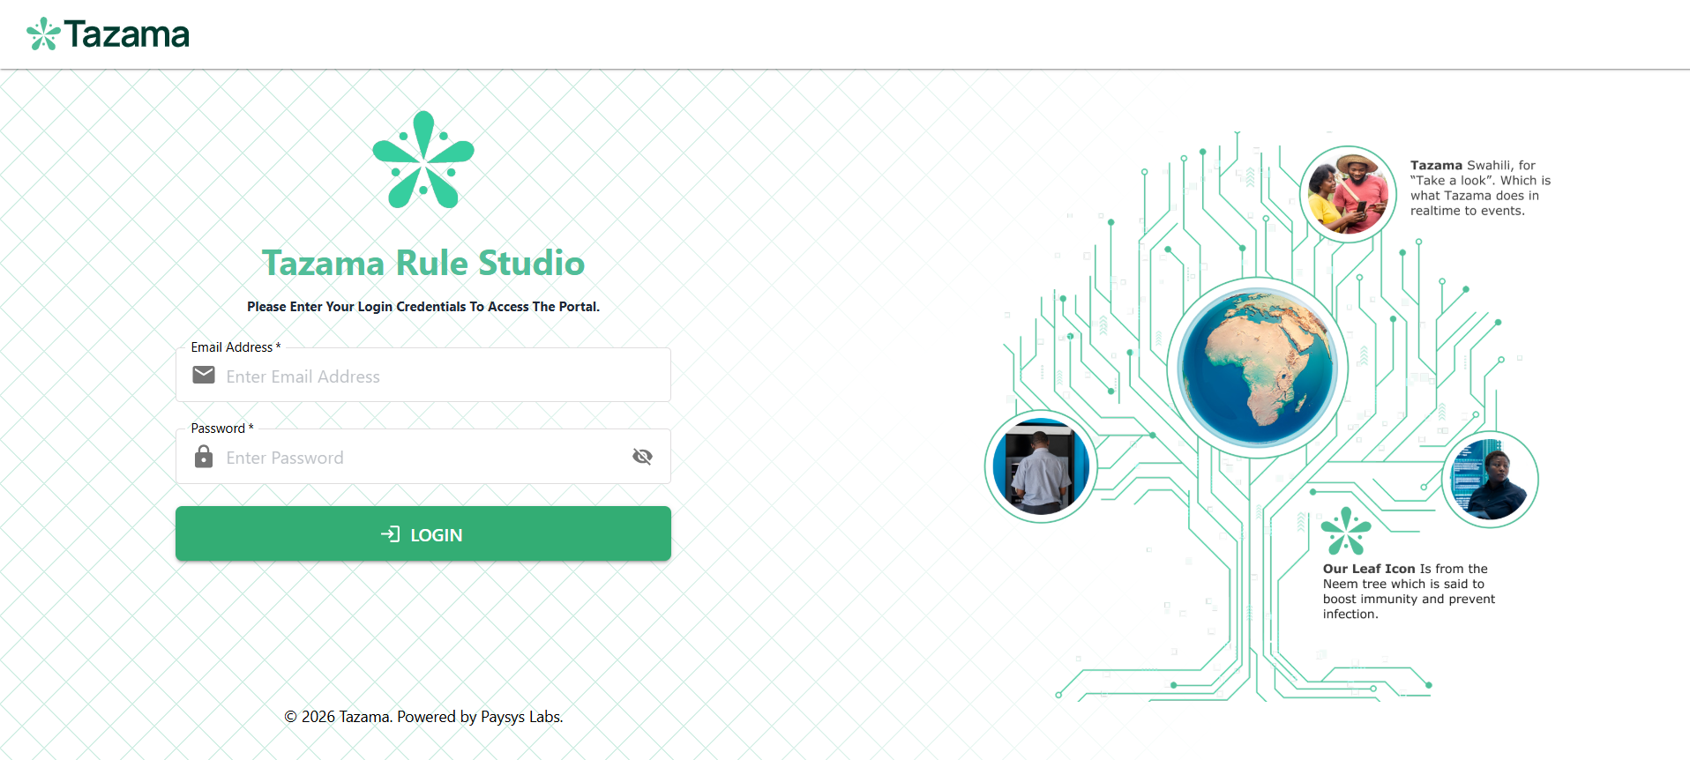
Figure 2: The TRS login screen — enter your assigned credentials to access the system.
TRS uses Role-Based Access Control (RBAC), which means the moment you log in, the system applies your role permissions automatically. You’ll only see the features and actions that are relevant to your role — Maker, Checker, or Deployer.

Keeping Your Session Secure
Once authenticated, a secure session is established.
- Your session will expire automatically if left inactive for too long — this is a security measure.
- If your session times out mid-task, just log back in and you can pick up where you left off.
- When you’re done for the day, always log out explicitly — especially before leaving your workstation.

Your Rule Dashboard
This is your home base in TRS. From here you can see every rule in the system — its name, version, current status, and what actions are available to you right now. Whether you’re a Maker picking up where you left off, a Checker working through a queue of submissions, or a Deployer checking what’s ready to go live, the dashboard gives you the complete picture.
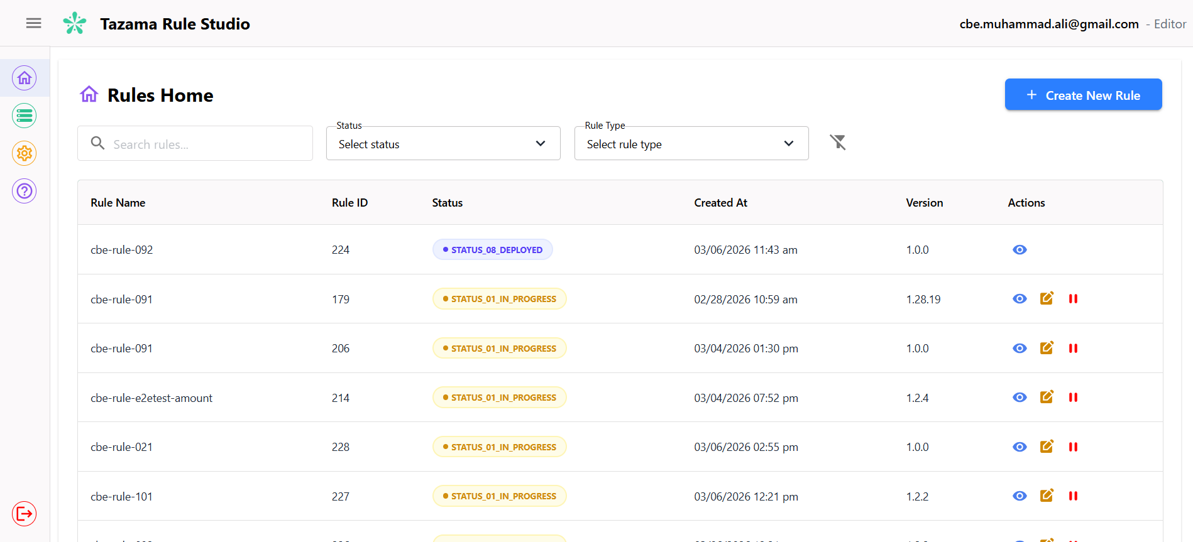
Figure 3: The Rule Dashboard — your home base showing every rule's name, version, status, and available actions.

Finding the Rule You Need
Use these filters individually or in combination to quickly find what you’re looking for:
- Rule Name (Free-text search)
- Rule Type
  - Fraud
  - AML
  - Fraud & AML (Combined)
- Status
  - In-Progress
  - Under Review
  - Approved
  - On Hold
  - Rejected
  - Deployed

Understanding Rule Statuses
Every rule moves through a defined set of statuses as it progresses from creation to deployment. The system enforces these transitions — you can’t skip steps, and the actions available to you depend entirely on where the rule is right now. For the full lifecycle flow, refer to the How a Rule Gets Built & Deployed section of this manual.
The rule can be in one of the following statuses:
- In Progress: The rule is being created or modified by the Maker and is not yet submitted for review.
- Under Review: The rule has been submitted to the Checker and is pending validation and approval.
- Approved: The rule has successfully passed review and is authorised for deployment by the Deployer.
- Deployed: The rule is actively implemented in the production environment and operational.
- On Hold: Allows the Maker to temporarily suspend rule development without deleting the draft.
- Rejected: Assigned by the Checker when revisions are required before approval.

What Can You Do with a Rule?
The actions available on a rule depend on your role and the rule’s current status. Here’s what each action does and when you can use it:
- View: Provides read-only access to inspect the rule configuration, logic, parameters, and metadata without allowing modification.
- Edit: Allows modification of rule logic and configuration. This action is permitted only when the rule is in either of the following statuses:
  - In Progress
  - On Hold
- Pause / Resume: Enables temporary suspension or reactivation of a rule configuration.
  - Pause: Temporarily suspends the rule configuration.
When paused, the rule status changes to On Hold.
  - Resume: Reactivates a previously paused rule.
Upon resumption, the rule status reverts to In Progress.
- Clone: Generates a new rule instance with a new Rule ID, allowing safe iteration, or alternative scenario development without impacting the original configuration. This action is permitted only when the rule is in:
  - Under Review
  - Approved

Setting Up Your Rule
Before you can build any logic, you need to lay the groundwork. This section covers the two steps that happen before you set foot on the Rule Builder canvas.

Step 1: Give Your Rule an Identity
Rule Overview is the starting point for every new rule. Think of it as filling in your rule’s identity card — you’re telling TRS what the rule is called, what kind of risk it targets, and which transaction type it applies to.
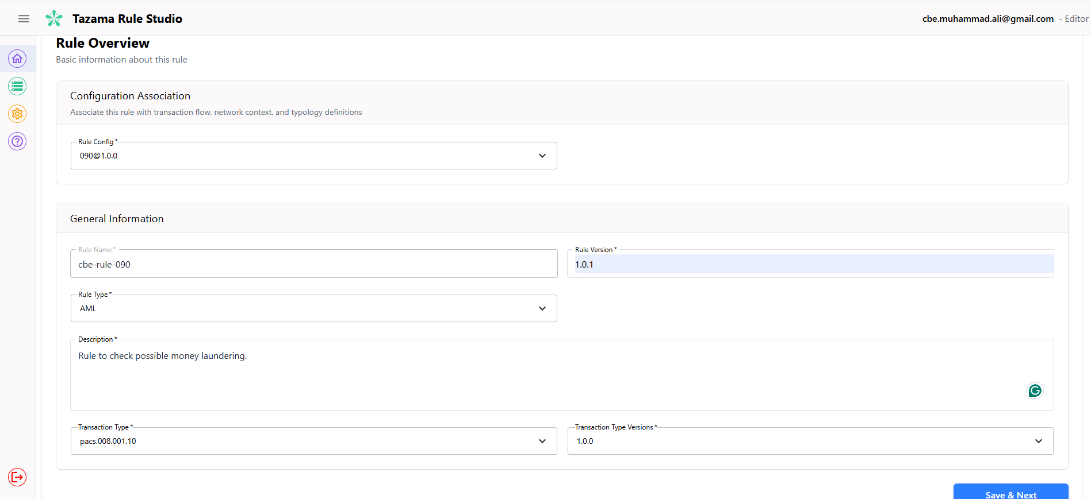
Figure 4: The Rule Overview form — give your rule an identity before building any logic.
Get this right and everything that follows will be properly scoped and connected.

Choosing the Right Configuration
Start by selecting a Rule Configuration. This single choice shapes the entire context of your rule — it determines the transaction flow, the network map, and which typologies your rule will belong to. Specifically, the configuration:
- Defines the applicable transaction schema
- Aligns the rule to a specific message type or processing flow
- Ensures compatibility with simulation and deployment environments
Once you’ve made your selection, your rule is locked into that configuration’s structure for its entire lifecycle.
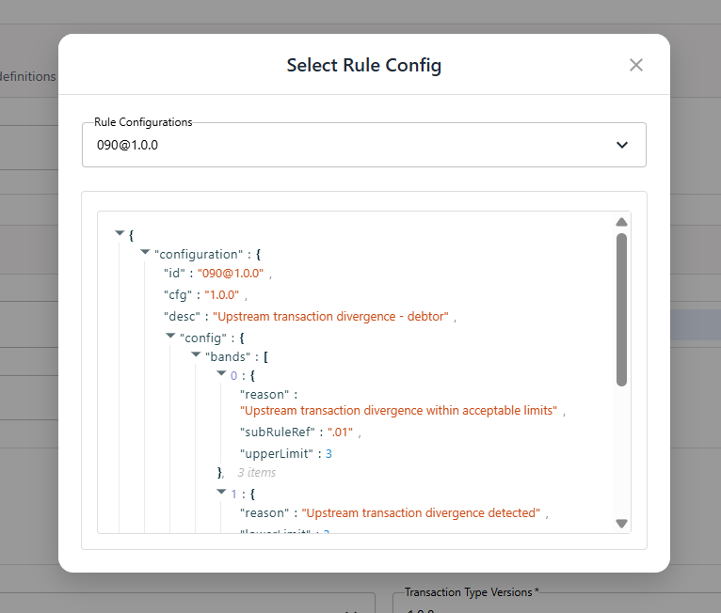
Figure 5: The Rule Configuration selection dropdown — this single choice scopes your entire rule.

Filling in the Rule Details
Next, fill in the details that give your rule its identity:
- Rule Name (Mandatory): A unique, business-readable identifier for the rule. This name will be visible in dashboards, status tracking, and audit logs.
- Rule Version (Mandatory): Specifies the version number of the rule configuration. Versioning supports controlled revisions and traceability.
- Rule Type (Mandatory): Classifies the rule under one of the supported domains:
  - Fraud
  - AML
  - Fraud & AML
- Description (Mandatory): A clear, structured explanation of the rule’s purpose, logic intent, and detection objective.
- Transaction Type (Mandatory): Specifies the transaction category to which the rule applies.
- Transaction Type Version (Mandatory): Defines the schema version of the selected transaction type to ensure rule compatibility with message structure.

Ready to Move On?
When all mandatory fields are filled in:
- The user selects Save and Next
- The system validates required inputs
- The rule remains in In Progress status
- The user is redirected to the next step (Rule Request)
All your inputs are saved at this point.

Step 2: Know Your Data
The Rule Request screen is a read-only reference panel that appears after the Maker completes Rule Overview. It displays the full structured payload that TRS constructs for the selected Rule Configuration, giving the Maker full visibility of the data available before building rule logic. No inputs are required on this screen; its purpose is to orient the Maker to the exact field paths, variable names, and data shapes they can reference and drag-and-drop into the Rule Builder.
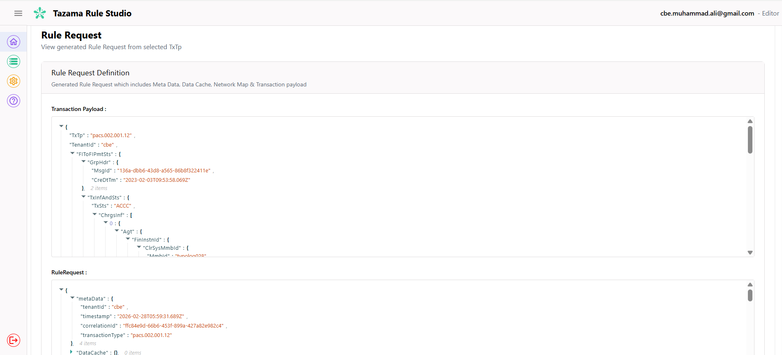Figure 6: The Rule Request screen showing the full structured payload: Metadata, DataCache, Network Map, and Transaction object.
The Rule Request is composed of four components:

Metadata
The metaData object contains envelope-level information about the transaction event being processed. It is populated by TRS and the Tazama platform and is not editable by the Maker. The fields present in this object are:
- tenantId — Identifies the tenant context under which the rule is evaluated. Rules are always scoped to a single tenant.
- timestamp — The ISO 20022 datetime at which the Rule Request was generated. Useful for time-sensitive rule conditions.
- correlationId — A unique identifier (UUID) that links the Rule Request to its originating event across the Tazama processing pipeline. Used for tracing and audit purposes.
- transactionType — The ISO 20022 message type of the transaction being evaluated (e.g. pain.001.001.11). This matches the Transaction Type selected during Rule Overview and determines the structure of the transaction payload below.

DataCache
The DataCache object contains a set of pre-resolved, frequently accessed identifiers derived from the transaction. These values are cached by the platform before rule execution to avoid redundant field lookups inside rule logic. The DataCache typically includes:
- cdtrId — The resolved identifier for the creditor (recipient) party.
- dbtrId — The resolved identifier for the debtor (sender) party.
- cdtrAcctId — The resolved account identifier for the creditor.
- intrBkSttlmAmt — The interbank settlement amount and currency, extracted and cached for efficient access by rules that evaluate transaction value.
Pro tip: DataCache fields are available as drag-and-drop variables in the Rule Builder. Use them whenever you can — they’re the quickest way to reference party and amount identifiers without digging through the full transaction object.

Network Map
The networkMap defines how the transaction is routed through the Tazama processing network. It specifies which Typology Processors will evaluate the transaction and which rules each typology depends on. The network map is configuration-driven and is not constructed by the Maker — it is determined by the Rule Configuration selected in Rule Overview.
The network map is structured as a hierarchy: at the top level, it defines one or more messages, each associated with a transaction type (txTp). Each message contains one or more typologies, and each typology lists the rules it requires. Each rule entry carries an id (the rule identifier and version) and a cfg (the configuration version to apply). Use the network map to understand where your rule sits in the bigger picture — which typologies depend on it and how it connects to the broader detection chain.

Transaction Payload
The transaction object contains the full ISO 20022 message payload for the transaction type selected during Rule Overview. This is the primary data source for rule logic. Its structure matches the ISO 20022 schema for the relevant message type — for example, a pain.001.001.11 Credit Transfer Initiation message will contain a CstmrCdtTrfInitn root object with group header, payment information, and credit transfer details nested within it.
Here are the fields you’ll most commonly reference when building rule logic:
- Debtor and creditor identifiers — Party IDs, account IDs, and contact details nested under PmtInf.Dbtr and CdtTrfTxInf.Cdtr.
- Transaction amounts — Instructed and equivalent amounts under CdtTrfTxInf.Amt, including currency.
- Timestamps and dates — Creation datetime (GrpHdr.CreDtTm) and requested execution date (ReqdExctnDt), used in time-window and velocity rules.
- Purpose and remittance codes — Payment purpose (Purp.Cd) and regulatory reporting codes, useful for classification-based rules.
Every field you see here is available as a drag-and-drop variable in the Rule Builder. The field paths follow the ISO 20022 object hierarchy exactly as shown. When in doubt about a field name or its nesting, come back to this screen — it’s your ground truth.

Building Your Rule
The Rule Builder is the visual rule construction engine within Tazama Rule Studio (TRS). It enables users to design, configure, and manage rule logic using a drag-and-drop flow-based interface.
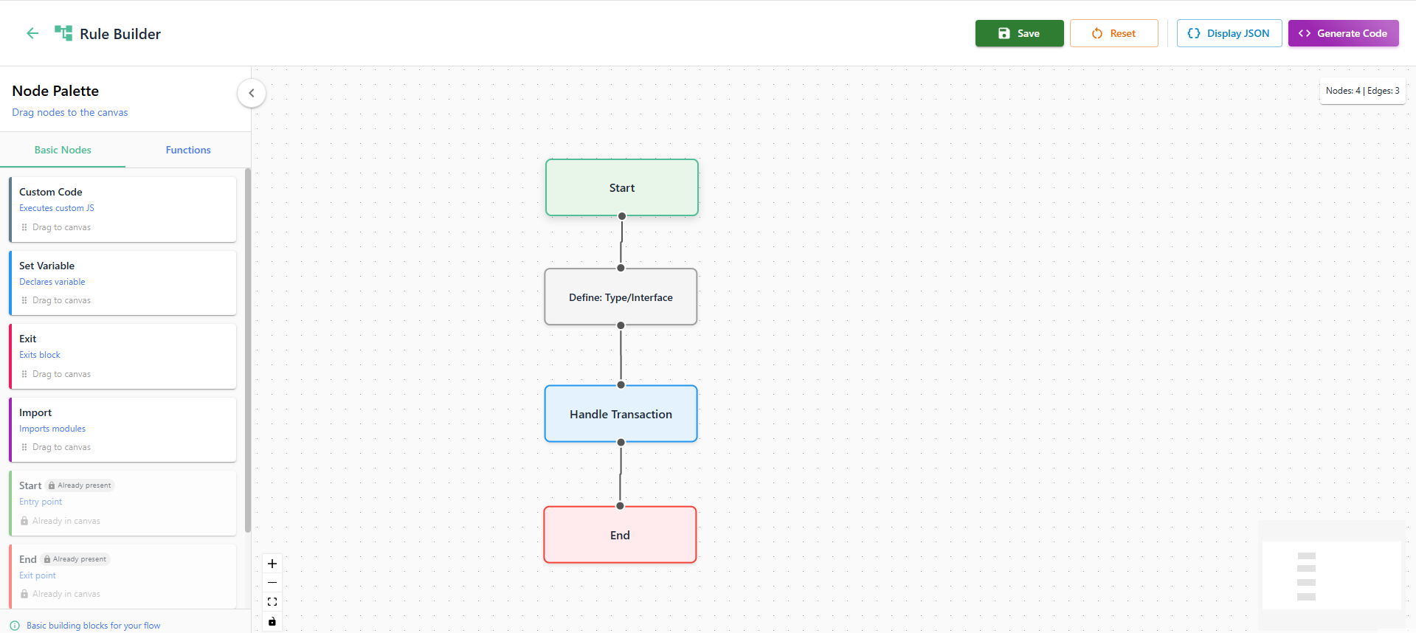
Figure 7: The Rule Builder canvas with the default base template loaded. The Node Palette is visible on the left.

How the Canvas Works
Each node on the canvas represents a specific operation — declaring a variable, evaluating a condition, calling a function, and so on. You connect them in the order you want them to execute, and TRS handles the conversion to runnable TypeScript.
The basic flow looks like this:
- Dragging nodes onto the canvas
- Configuring node parameters
- Connecting nodes to define execution flow
- Saving and generating rule logic
When you’re ready, TRS compiles your canvas into structured, executable TypeScript automatically.

What You Can Do
- Drag and drop Nodes:
Drag nodes from the Node Palette onto the canvas. Each node is a building block:
  - Variable declaration
  - Object manipulation
  - String operations
  - Math operations
  - Custom functions
  - Predefined functions
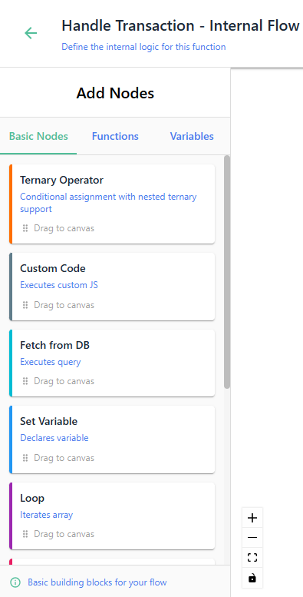
Figure 8: The Node Palette showing available node categories: Basic Nodes, Functions, and Variables.
- Add connections between the nodes:
Connect nodes by linking output connectors to input connectors. The rule runs from the Start node to the End node in the order you define. Connections control:
  - Execution sequence
  - Data flow
  - Logical dependencies

Node Reference

Main Canvas
- Basic Nodes:
  - Print Log: Outputs a specified message to the system log during rule execution. Primarily used for debugging, traceability, and validating intermediate values within a rule flow.
Field Name | Description | Expected Value
Message* | Defines the message that will be written to the system log when the node executes. The message may contain static text or dynamic variables from the workflow context. | Example: 'This is a Print Message'

  - Custom Code: Executes user-defined JavaScript logic within the rule flow to perform advanced calculations or dynamic evaluations. Used when built-in nodes are insufficient, and bespoke processing or conditional handling is required.
Field Name | Description | Expected Value
Code* | Contains the JavaScript code to be executed when the node is reached. This field allows users to input custom logic, which will run at runtime. | Example: console.log('Hello');

  - Set Variable: Declares and initializes a variable within the rule execution context for use in subsequent nodes. Used to store intermediate values, counters, thresholds, or computed results during rule processing.
Field Name | Description | Expected Value
Variable Name* | The name of the variable being declared. This is the identifier used to reference the variable in the workflow. | Example: Amount
Declaration Type* | Specifies how the variable is declared. It can be set as a var, let, or const, depending on whether you want to allow reassignment (for var and let) or make the variable immutable (for const). | Options: var, let, const
Data Type* | Defines the data type of the variable. This ensures the variable holds the correct type of data. | Example: any, number, string, etc.
Value* | The value assigned to the variable at initialization. This can be a static value or an expression based on runtime calculations. | Example: 10, "Hello World"

  - Exit: Terminates execution of the current rule block based on the selected exit type (e.g., break, continue, return). Used to control rule flow by stopping, skipping, or finalizing processing at a defined point.
Field Name | Description | Expected Value
Exit Type* | Specifies the type of exit that should be performed. Depending on the chosen option, the flow will behave differently within the loop or block. | Options: break, continue, return

  - Import: Loads external modules or predefined libraries into the rule execution context. Used to access reusable functions, utilities, or shared logic within custom code blocks.
Field Name | Description | Expected Value
Import Statement* | Specifies the import statement for bringing in an external module or specific functions from a module. The statement follows the typical JavaScript import syntax. | Example: import { something } from 'module';

- Functions
  - Define: Type/Interface: Defines reusable TypeScript types or interfaces to structure and validate data used within the rule. Used to standardize variable/object shapes and improve clarity and safety when writing custom logic.
Field Name | Description | Expected Value
Type Kind* | Specifies whether the definition is a type or interface. Choosing type allows you to create a type alias, while interface is used for defining object structures and contracts. | Options: type, interface
Type Name* | The name of the custom type or interface being defined. This name will be used to reference the type/interface in the workflow. | Example: CustomType
Type Definition* | Defines the structure or properties of the type or interface. For a type, this could include unions, intersections, or primitive types. For an interface, this will define object properties and their types. | Example: { id: string; name: string; }

  - Define: Custom Function: Creates a reusable, user-defined function that can be invoked elsewhere within the rule flow. Used to encapsulate complex or frequently used logic into a structured, parameterized function for modular and maintainable rule design.
Field Name | Description | Expected Value
Function Name* | Specifies the name of the custom function. This should be a valid JavaScript identifier and will be used to reference the function in the workflow. | Example: calculateTotal
Function Parameters | Defines the parameters that the custom function will accept. You can add multiple parameters with different data types. | Example: param1 (type: any)
Function Signature | Automatically generated based on the function name and parameters. This shows the function declaration format in JavaScript. | Example: export const calculateTotal = (...params) => { ... }
Function Code* | Contains the actual code logic for the custom function. This is where you define how the function should behave, processing inputs and returning a result. | Example: return params.reduce((acc, val) => acc + val, 0);

  - Define: Haversine Distance: A predefined function node that calculates the geographic distance (in kilometres) between two coordinate pairs using the Haversine formula. The function code is pre-loaded into the node and does not require manual input under normal use. It can be reviewed or modified by the Maker if custom behavior is required.
The function accepts two latitude/longitude pairs and returns the distance between them as a number. It is typically used in combination with a Call: Haversine Distance node, which invokes it elsewhere in the rule flow. This node must be defined before any Call: Haversine Distance node can reference it.

  - Define: Standard Deviation: A predefined function node that calculates the standard deviation of a numeric dataset. The function code is pre-loaded and does not require manual input under normal use. It can be reviewed or modified by the Maker if custom behavior is required.
The function accepts an array of numbers and returns a single numeric value representing the spread of the dataset. Standard deviation is used in rules that need to detect anomalous values — for example, a transaction amount that falls significantly outside a debtor’s historical spending pattern. This node must be defined before any Call: Standard Deviation node can reference it.

  - Define: Handle Transaction: Defines the main transaction handling logic and opens a nested canvas. The nested canvas provides access to a richer set of nodes including loops, conditionals, database queries, and function calls, enabling the construction of complex, multi-step rule logic within a contained execution context.

Nested Canvas
- Basic nodes
  - Ternary Operator: Evaluates a condition and returns one value if true and another if false, with support for nested conditional logic. Used for compact, conditional value assignment within the rule flow without creating multiple separate branches.
Field Name | Description | Expected Value
Result Variable* | Specifies the variable where the result of the ternary operation will be stored. This value is the result of the conditional logic (true or false) evaluated in the condition. | Example: ternaryResult
Root Condition* | Defines the condition that will be evaluated. This should be a boolean expression or variable that returns true or false. | Example: true, x > 5, isValid
If True | The value that will be returned when the root condition evaluates to true. | Example: 'yes'
If False | The value that will be returned when the root condition evaluates to false. | Example: 'no'
Add Nested Condition | This option allows the addition of nested conditions inside the true or false branches for more complex logic. These conditions can return values or contain additional ternary operations. | Example: Add further conditions within true/false branches.

  - Print Log: Same as described in Main Canvas.
  - Custom Code: Same as described in Main Canvas.
  - Fetch from DB: Executes a database query to retrieve data from a selected data source during rule execution. Used to access historical, configuration, or transactional records required for rule evaluation, displaying the first 5 rows of result.
Field Name | Description | Expected Value
Database* | Specifies the database to query. The user selects the database where the data resides. | Example: _event_history
SQL Query* | Contains the SQL query to be executed. The user writes the query that retrieves the necessary data from the database. | Example: SELECT * FROM users WHERE active = 1;
Store Query in Variable* | Defines the variable in which the SQL query string will be stored for later use. | Example: query
Store Result In* | Specifies the variable where the query result (data) will be stored. The result can then be used in later nodes in the workflow. | Example: data

  - Set Variable: Same as described in Main Canvas.
  - Loop: Iterates over an array or dataset using the selected loop type (e.g., forEach, map, filter, reduce). Used to evaluate, transform, or aggregate multiple records dynamically within a single rule execution.
Field Name | Description | Expected Value
Loop Type* | Specifies the type of loop to be executed. It can be a map, forEach, or other looping types. | Example: map
Array Variable* | Defines the array of items that will be iterated over in the loop. This variable holds the data being processed. | Example: {{ queryResult.rows }}
Item Variable* | Specifies the variable used to store each item during the loop iteration. This variable is used inside the loop to reference the current item. | Example: r
Index Variable | Defines the variable used to store the index of the current item during iteration. | Example: index
Result Variable* | Specifies the variable where the loop results will be stored after processing. | Example: loopResult
Condition (every/some/find loop only) | Defines a condition that must be met for the loop iteration to proceed. This can filter items in the array. | Example: Number(r.Amt)

  - Exit: Same as described in Main Canvas.
  - If Condition: Evaluates one or more Boolean expressions and routes execution based on the outcome (If / Else If / Else). When Else If or Else clauses are added, additional connectors appear on the main If node. Used to implement decision-making logic and control rule flow through defined conditional branches.
Field Name | Description | Expected Value
If Condition* | Defines the primary boolean expression that will be evaluated. If the condition evaluates to true, the workflow follows the IF branch; otherwise it proceeds to evaluate the next condition or fallback path. | Example: !{{ RuleConfig. config.bands }}
Else If Condition | Allows additional conditional checks if the main If Condition evaluates to false. Multiple Else If conditions can be added to handle additional branching logic. | Example: y > 10
Else (Fallback Path) | Defines the default execution path when none of the If or Else If conditions evaluate to true. | No condition required, just connection to another outcome

  - Throw Error: Raises a runtime error with a specified message and halts rule execution. Used to enforce validation checks or stop processing when critical conditions are not met.
Field Name | Description | Expected Value
Error Message* | Specifies the message that will be returned or logged when the error is triggered. This message helps identify the reason for the workflow failure and can include static text or variables. | Example: Unsuccessful transaction

- Functions
  - Use: Type/Interface: References a previously defined Type or Interface by name, making it available within the current scope. The type or interface must have been declared earlier in the flow using a Define: Type/Interface node.
  - Object Operation: Performs predefined operations on an object, such as retrieving keys, values, entries, assigning properties, or checking ownership. Used to inspect, manipulate, or restructure object data within the rule execution flow.
Field Name | Description | Expected Value
Object* | Specifies the object that the operation will be performed on. This object can be a variable or a data structure that contains multiple properties. Users can drag-and-drop an object from the Variables panel. | Example: {{ RuleRequest.pain001 }}
Operation* | Defines the operation to be applied to the object. The operation can include standard methods like keys, values, or custom operations specific to the workflow. | Example: keys or values
Result Variable* | Specifies the variable where the result of the operation will be stored. This allows you to reference the result later in the workflow. | Example: objectResult

  - String Function: Applies predefined string operations to a given string value. Used to transform, format, or extract specific portions of textual data within the rule flow.
Field Name | Description | Expected Value
String* | Specifies the string to which the operation will be applied. This can be a variable or a literal string value that needs to be processed. | Example: {{ RuleResult.id }}
Operation* | Defines the string operation to be performed. Common operations include trimming whitespace, converting to uppercase, or other string manipulations. | Example: trim
Result Variable* | Specifies the variable where the result of the string operation will be stored. This variable will hold the processed string value. | Example: stringResult

  - Call: Custom Function: Invokes a previously defined custom function within the rule flow. Used to execute reusable logic with specified parameters and obtain the function’s returned result for further processing.
Field Name | Description | Expected Value
Select Function to Call* | Specifies the custom function that will be invoked by this node. The function must be previously defined in the workflow using a Define: Custom Function node. | Example: calculateTotal, processData

  - Math Function: Performs predefined mathematical operations on numeric inputs. Used to compute, transform, or normalize numerical values within the rule execution flow.
Field Name | Description | Expected Value
Operation* | Specifies the math operation to be performed. Common operations include absolute, sin/cos/tan, square root, power, etc. | Example: pow (for power)
Value1* | Defines the first value or variable used in the operation. This can be a static number or a variable from the workflow. | Example: 2, {{ x }}
Value2 | Defines the second value or variable used in the operation (only relevant for operations that require two inputs like pow). | Example: 3, {{ y }}
Result Variable* | Specifies the variable where the result of the math operation will be stored for further use in the workflow. | Example: mathResult

  - Call: Haversine Distance: Invokes the predefined Haversine Distance function to compute the distance. Used to obtain a location-based distance value for anomaly detection or geospatial rule evaluation.
Field Name | Description | Expected Value
Result Variable Name* | Defines the variable where the result of the function call will be stored. This variable will contain the output of the function for later use in the workflow. | Example: distance
Latitude 1 (number)* | Specifies the first latitude value (in degrees) to be passed as an argument to the function. This can be a variable or a numeric value. | Example: lat1 or 40.7128
Latitude 2 (number)* | Specifies the second latitude value (in degrees) to be passed as an argument to the function. | Example: lat2 or 34.0522
Longitude 1 (number)* | Specifies the first longitude value (in degrees) to be passed as an argument to the function. | Example: long1 or -74.0060
Longitude 2 (number)* | Specifies the second longitude value (in degrees) to be passed as an argument to the function. | Example: long2 or -118.2437

  - Call: Standard Deviation: Invokes the predefined Standard Deviation function to calculate variability within a numeric dataset. Used to retrieve dispersion metrics for detecting abnormal transactional or behavioral patterns
Field Name | Description | Expected Value
Result Variable Name* | Defines the variable where the result of the function call will be stored. The result of the standard deviation calculation will be stored here for use in later steps. | Example: stdDev
Array of values (number[])* | Specifies the array of numbers whose standard deviation needs to be calculated. This can be a variable containing an array of values or a manually entered array. | Example: values or [10, 12, 15, 18, 22]

  - Destructure: Extracts specified keys from a source object and assigns them to individual variables. Used to simplify access to object properties for clearer and more efficient rule logic.
Field Name | Description | Expected Value
Source Object* | Specifies the object from which properties will be extracted. This should reference an existing object variable or template within the workflow. | Example: {{ RuleRequest.pain001 }}
Keys* | Defines the object properties to extract from the source object. Multiple keys should be provided as comma-separated identifiers. The extracted values will become available as variables in the workflow. | Example: id, name, amount

  - Array Operation: Performs predefined operations on an array (e.g., pop, push, shift, sort, etc.). Used to modify, inspect, or manipulate array data during rule execution.
Field Name | Description | Expected Value
Array* | Specifies the array on which the operation will be performed. This should reference a valid array variable or template available in the workflow. | Example: {{ queryResult.rows }}
Operation* | Defines the array operation to be applied. Common operations include pop, push, concat, reverse, etc., depending on the intended manipulation of the array. | Example: pop
Result Variable | Specifies the variable where the result of the array operation will be stored. | Example: arrayOpResult

- Variables
In the workflow canvas, you can drag and drop variables into any node that accepts them. Variables come in two flavours: global variables (pre-loaded from the RuleRequest, RuleConfig, and RuleResult) and local variables (ones you create yourself using Set Variable nodes, scoped to your specific logic).
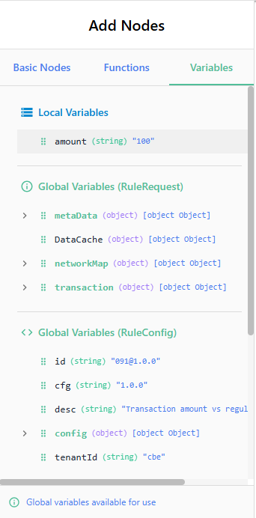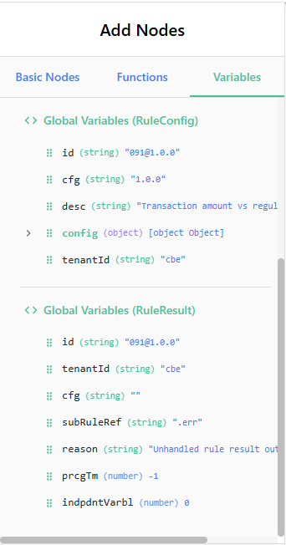
Figure 9: The Variables panel showing global variables (from RuleRequest, RuleConfig, RuleResult) and any local variables you have defined.

Previewing the Generated Code

How Code Generation Works
Click Generate Code at any point to see your canvas as TypeScript. TRS analyses every node and connection and compiles them into structured, readable code.
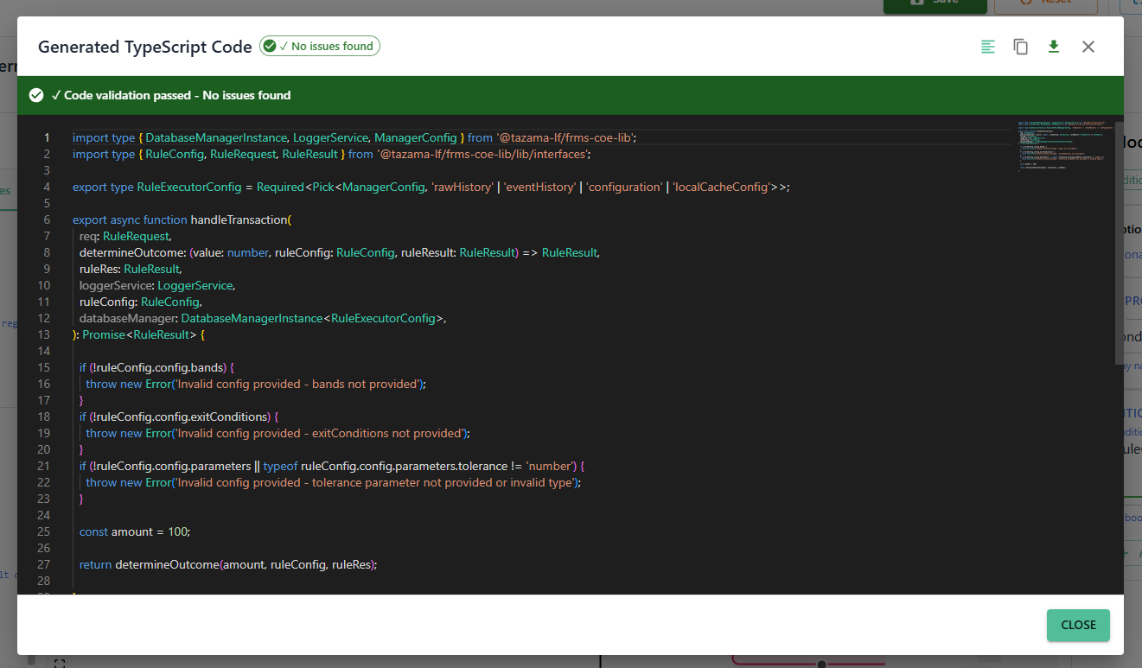
Figure 10: The Generate Code view showing compiled TypeScript output. The Errors panel is visible at the top.
Use this to verify your logic is sound, share the implementation with a Checker for review, or simply satisfy your own curiosity about what the canvas is producing.

Spotting Errors Before They Cause Problems
Every time you generate code, TRS automatically checks for basic syntax issues. Any problems are listed in the Errors panel at the top of the code viewer.
For example:
- Undefined variables
- Missing references
- Invalid syntax within custom code blocks
Each entry shows the line number and a description, so you can find and fix issues quickly. This is a syntax check only — it won’t catch logic errors or runtime behaviour. That’s what simulations are for.
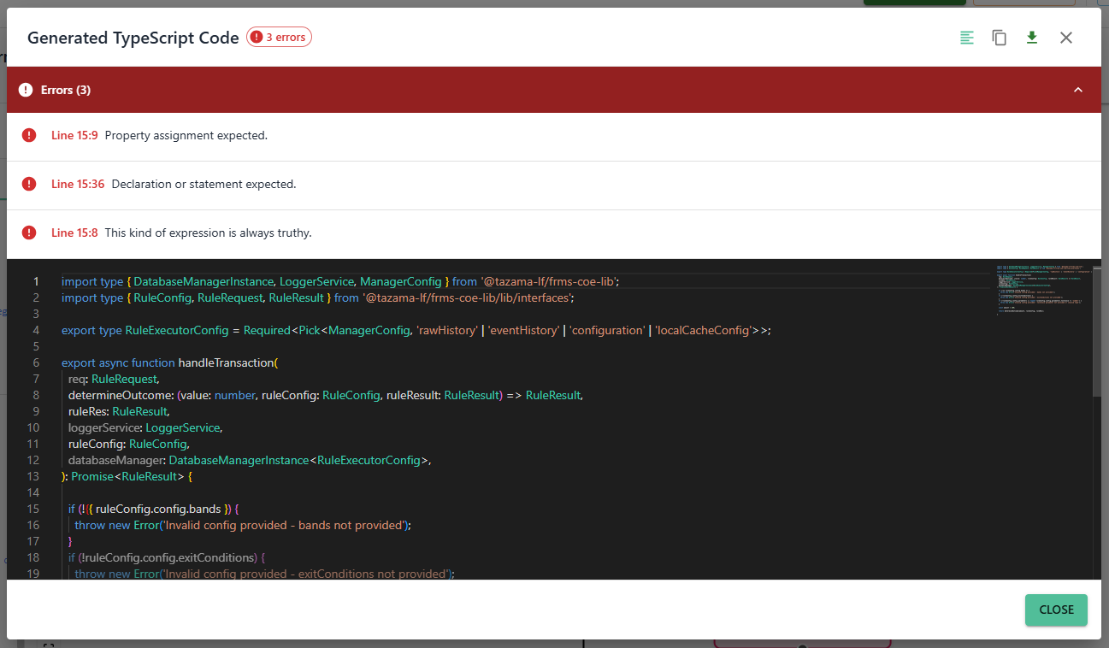Figure 11: The Errors panel listing syntax issues with line numbers and descriptions — fix these before proceeding.
Once you’ve fixed the issues on the canvas, regenerate the code to confirm it compiles cleanly.

Viewing the JSON
The Display JSON button generates a JSON representation of the workflow built on the canvas. When clicked, it converts the entire flow, including all nodes, their properties, and relationships, into a structured JSON format. This is particularly useful for sharing, exporting, or versioning the workflow configuration. Each node in the workflow, along with its parameters, labels, and position, is represented in the JSON output. Additionally, if there are any nested flows or sub-processes, those are also included in the JSON structure. This output can be saved, copied, or used to recreate the workflow programmatically or in other systems. The JSON Output window provides an easy-to-read structure, making it simple to inspect the workflow’s internal representation.
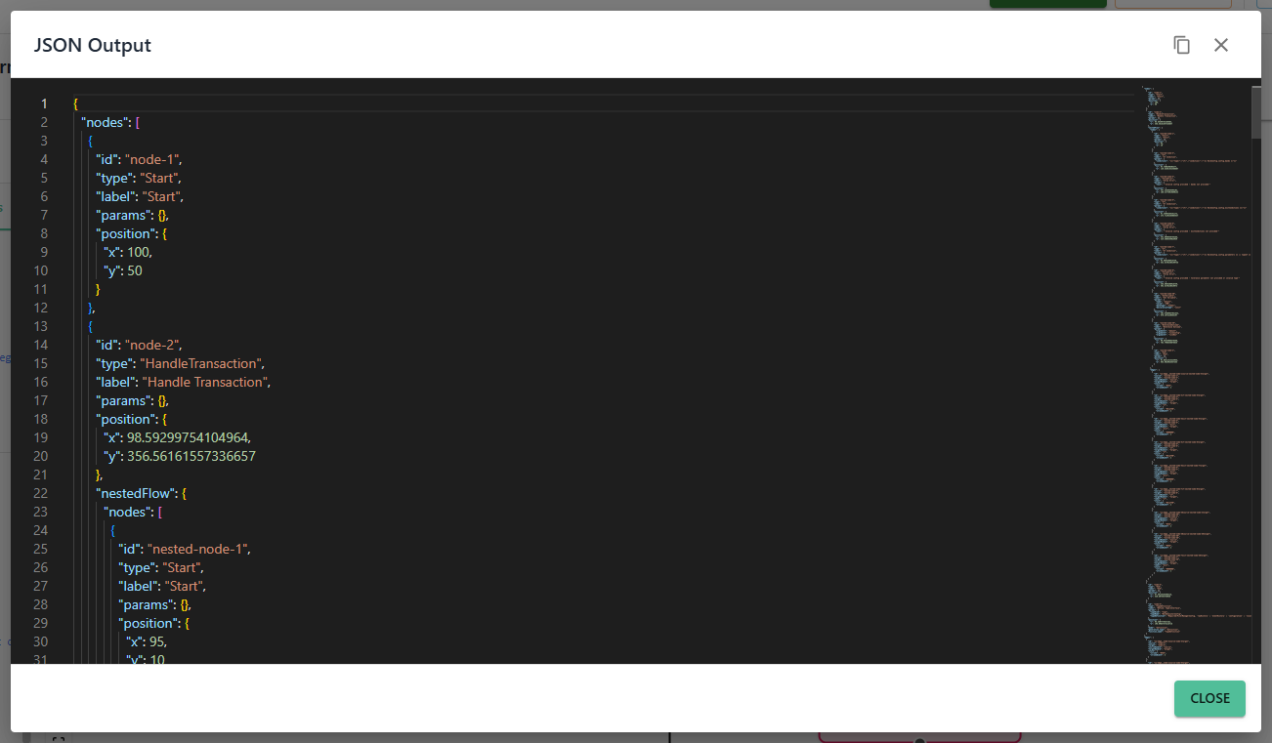
Figure 12: The JSON equivalent of the current status of the Rule Builder Canvas

Saving Your Work
Click Save Rule to save everything on your canvas — nodes, connections, parameters, and all. Your rule is stored in TRS and can be retrieved, edited, or continued at any time. Save often; the canvas doesn’t auto-save.

When to Reset Canvas
By default, the canvas opens with the preloaded base template — a set of predefined nodes covering common rule patterns. When you need a completely clean slate, clicking Reset Canvas clears the full template and leaves you with a minimal skeleton containing only what’s needed to start from scratch.
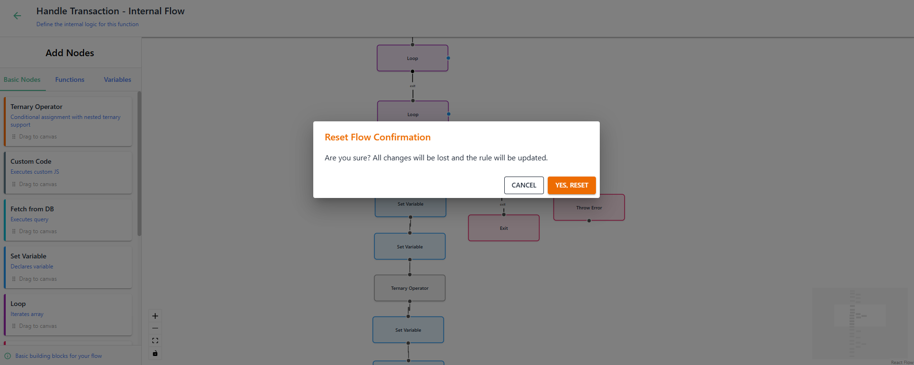
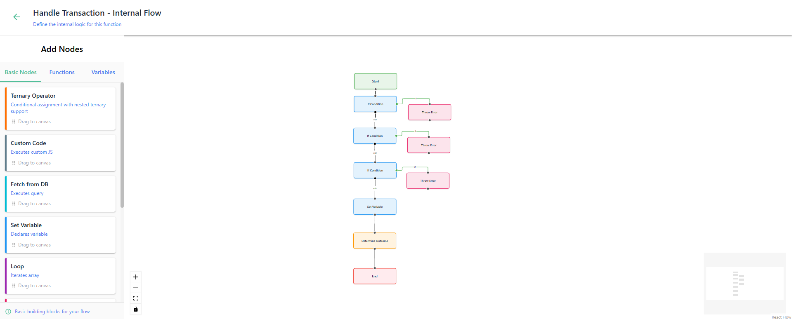
Figure: 13: the canvas with the full base template. 14: the minimal skeleton after clicking Reset Canvas.
This option is provided so that users who wish to create simple or highly customized rules can work with a cleaner and less cluttered canvas, making it easier to design the logic according to their specific requirements without having to remove or modify the predefined components.

Testing Your Rule

Why Test Your Rule?
The Test Case Builder gives you a dedicated canvas to define, organise, and run tests against your rule. You build your test scenarios here — what inputs to use, what outcomes to expect, and what conditions to validate — before your rule ever reaches the Checker.
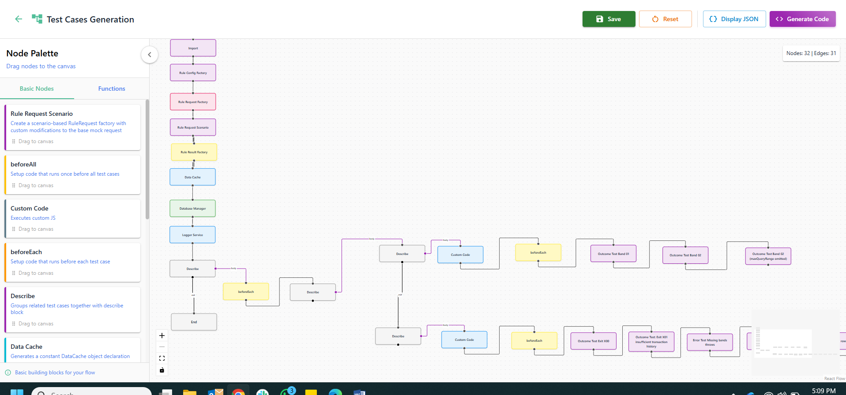Figure 15: The Test Case Builder canvas with the base template loaded, showing predefined test function nodes.
Think of it as your quality gate. The more thoroughly you test here, the more confident you can be when you hit Send for Approval.

Building Your Test Cases
- Drag and drop Nodes:
Drag nodes from the Node Palette onto the canvas. Each node is a building block:
  - Imports declaration
  - Setup blocks
  - Describe blocks
  - Factory functions
  - Predefined test functions
- Add connections between the nodes:
Just like in the Rule Builder, connect nodes by linking output to input connectors. The test runs from Start to End in the order you define. Connections control:
  - Execution sequence
  - Data flow
  - Logical dependencies

Test Case Generator Nodes

Main Canvas
- Basic Nodes:
  - Rule Request Scenario
Creates a scenario-based RuleRequest factory with custom modifications to the base mock request, allowing users to simulate different rule conditions.
  - beforeAll
A setup node that runs once before all test cases, typically used for preparing shared resources or configurations.
  - Custom Code
Allows writing code into an editor. Executes custom JavaScript code, allowing to include any bespoke logic or additional functions in the test case flow.
  - beforeEach
A setup node that runs before each individual test case, useful for initializing conditions or resetting values for each test case. Code is preloaded and editable.
  - Describe
Groups related test cases together, creating a describe block for better organization and readability of the test structure. You can change the label of the describe blocks according to the grouping of tests.
  - Data Cache
Generates a constant DataCache object declaration, allowing for predefined data caching during test case execution to optimize tests.
  - Rule Config Factory
Generates a factory function that returns a RuleConfig object, used for configuring rules during the testing process.
  - Rule Request Factory
Generates a factory function that returns a RuleRequest object, essential for creating mock request data for testing.
  - Database Manager
Declares a DatabaseManagerMock variable for testing, simulating database interactions during rule testing without using an actual database.
  - Logger Service
Declares a LoggerServiceMock variable for testing, enabling the simulation of logging actions during the testing process.
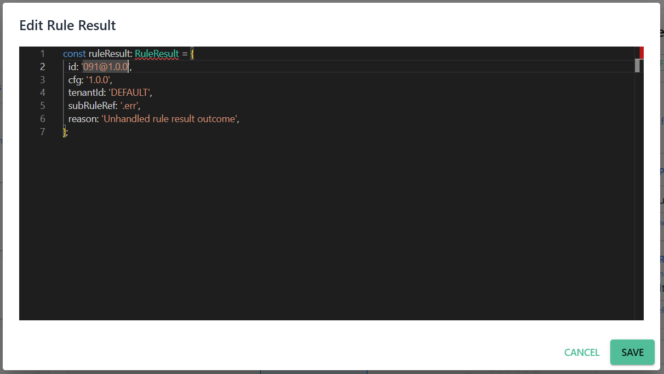
  - Rule Result Factory
Generates a factory function that returns a RuleResult object, helping to simulate and test rule outcomes in the workflow. Here, all you have to do it “Edit Rule Result”, and modify the configuration to match the rule ID you’re creating.
Figure 16: The Rule Result Factory node in Edit mode
  - Import
Contains preloaded imports, and allows the import of additional external functions, modules, or libraries that can be used within the testing environment to extend functionality.

- Functions
The predefined function nodes listed below are specific to the base rule template and are pre-populated with test code targeting known exit conditions and error scenarios of that template. They do not require manual configuration and will execute as-is, however the Maker can choose to edit any of the predefined nodes. If the Maker resets the canvas to build a rule from scratch, these nodes will not be present in the default skeleton and can be added selectively as needed.
- Custom Test
Allows users to write custom test code using the Monaco editor. This node provides flexibility for users to create and execute custom test logic tailored to specific needs.
- Error Test: Tolerance not number
A predefined function that tests error handling when the tolerance parameter is not a number. It ensures that the system correctly handles invalid input for tolerance values.
- Outcome Test Band 02 (maxQueryRange omitted)
A predefined function that tests the behavior of band .02 validation when the maxQueryRange parameter is omitted, checking how the system handles missing or incomplete input.
- Outcome Test: Exit X01 insufficient transaction history
A predefined function that tests the exit condition X01 when there is insufficient transaction history, validating how the system exits when certain transaction data is unavailable.
- Error Test: Array isn't numbers
A predefined function that tests error handling when an array contains non-numeric values, ensuring that the system can handle incorrect data types within arrays.
- Error Test: Missing exit conditions
A predefined function that tests error handling when the exit conditions configuration is missing, ensuring the system responds appropriately when exit conditions are not provided.
- Error Test: Bad or missing subRuleRef for ".x01"
A predefined function that tests error handling when the exit condition .x01 has a bad or missing subRuleRef, ensuring the system detects and handles this issue correctly.
- Error Test: No tolerance
A predefined function that tests error handling when the tolerance parameter is not provided, verifying how the system responds to the absence of this critical value.
- Outcome Test Exit X00
A predefined function that tests the exit condition X00 when an unsuccessful transaction occurs, checking if the system properly handles this scenario.
- Error Test: Missing bands throws
A predefined function that tests error handling when bands configuration is missing, ensuring the system throws the expected error when required band data is not present.
- Error Test: Empty rows
A predefined function that tests error handling when a query returns empty rows, ensuring the system handles this scenario correctly.
- Error Test: Bad or missing subRuleRef for ".x00"
A predefined function that tests error handling when the exit condition .x00 has a bad or missing subRuleRef, verifying that the system detects and handles this error properly.
- Outcome Test Band 01
A predefined function that validates the outcome for band 01 using database mock data and compares it with the expected results to ensure the rule's behavior is as intended.
- Outcome Test Band 02
A predefined function that tests band .02 validation when processing a significant number of transactions, ensuring the system handles large volumes of data correctly.

Previewing the Generated Test Code

How Code Generation Works
The Generate Code feature converts the visual workflow created on the canvas into TypeScript code. When this option is selected, the system analyzes all nodes and connections configured in the rule builder and compiles them into structured TypeScript logic representing the same workflow.
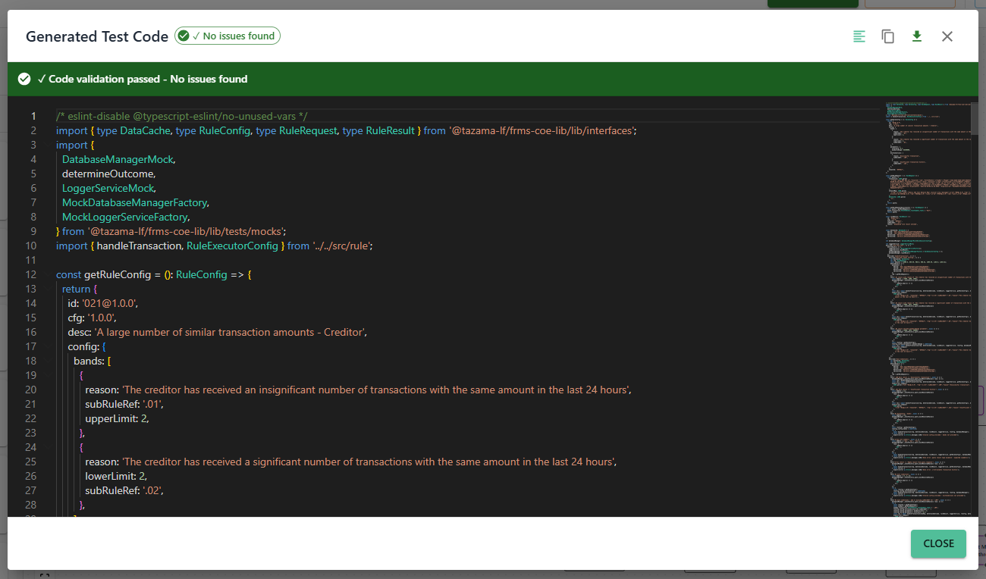
Figure 17: The generated TypeScript test code produced by the Test Case Builder's Generate Code feature.
Use this to verify your logic is sound, share the implementation with a Checker for review, or simply satisfy your own curiosity about what the canvas is producing.

Spotting Errors Before They Cause Problems
Every time you generate code, TRS automatically checks for basic syntax issues. Any problems are listed in the Errors panel at the top of the code viewer.
For example:
- Undefined variables
- Missing references
- Invalid syntax within custom code blocks
Each entry shows the line number and a description, so you can find and fix issues quickly. This is a syntax check only — it won’t catch logic errors or runtime behaviour. That’s what simulations are for.
Once you’ve fixed the issues on the canvas, regenerate the code to confirm it compiles cleanly.

Exporting as JSON
Click Display JSON to export your canvas as a structured JSON snapshot — useful for sharing, versioning, or recreating your configuration in another environment. Every node, its parameters, labels, position, and any nested flows are captured. The output window is clearly structured and easy to read.
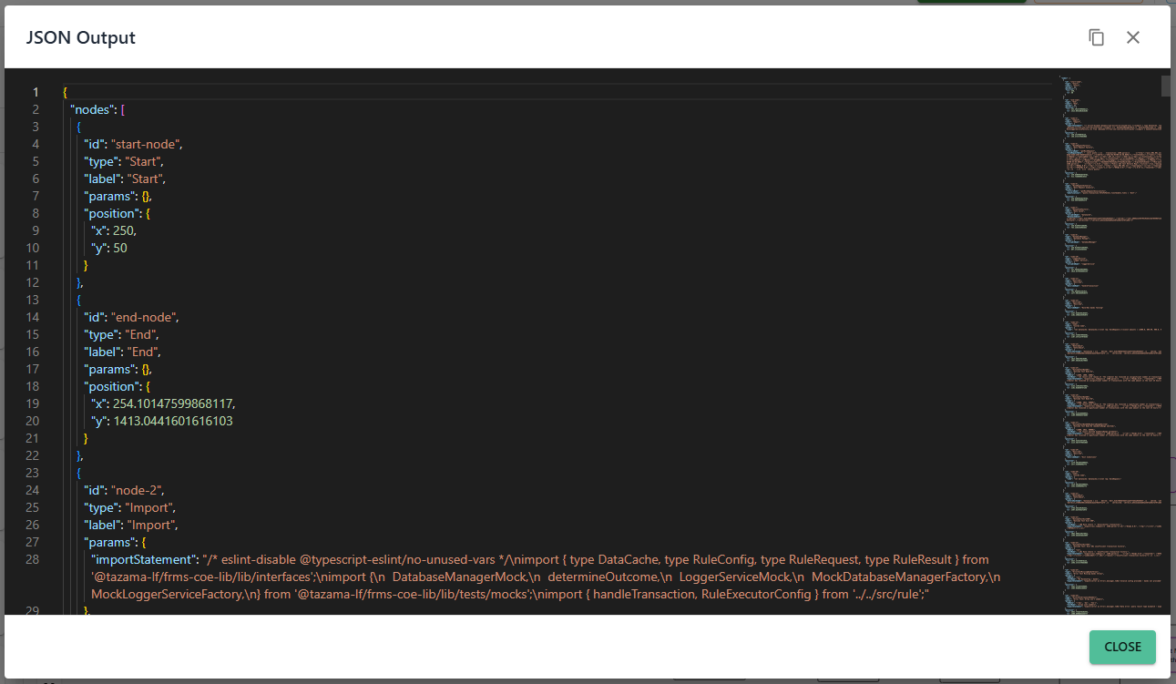
Figure 18: The Display JSON window showing the canvas serialised as structured JSON — ready to copy or save.

Saving Your Work
Click Save Rule to save your test case canvas. Everything is stored so you can come back, edit, and re-run your tests whenever you need to.

When to Reset
Resetting the Test Case Canvas clears everything and returns you to a lean starting template — just the essential nodes, no complex pre-built logic.
The reset template gives you these 4 components to build from:
- Describe: This node groups related test cases together in a logical block for better readability and organization.
- beforeEach: This node contains setup logic that runs before each test case, ensuring that necessary conditions are initialized or reset before running the tests.
- Custom Code: This node allows the user to insert custom JavaScript code, enabling flexible test logic as needed.
- Error Test Nodes: These nodes are predefined tests that check for specific error handling, such as when parameters like tolerance are missing or invalid. In the reset template, these basic error-handling tests are already defined for common error cases.
Starting from the skeleton means you can focus entirely on building exactly what your rule needs — without first clearing out nodes that don’t apply.
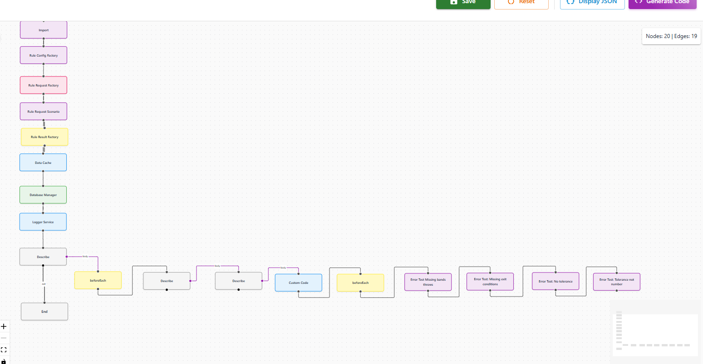
Figure 19: The minimal test case template after clicking Reset Canvas

Running Your Simulations
Before you submit your rule for review, you need to simulate it. Simulations are how you prove to yourself — and to the Approver — that your rule works. TRS gives you two modes: test your rule in isolation with a hand-crafted payload (Rule-Only), or put it through a real transaction pipeline via DEMS (DEMS-Driven). Use both to build confidence before submitting.

Getting Ready to Simulate
Before you can run any simulation, you need to push your latest work into the environment. It’s a two-step process: first click Sync to GitHub to commit your rule and test case files to GitHub, then click Deploy Rule to push everything from the Staging branch to the DEV branch so that simulations can be run.
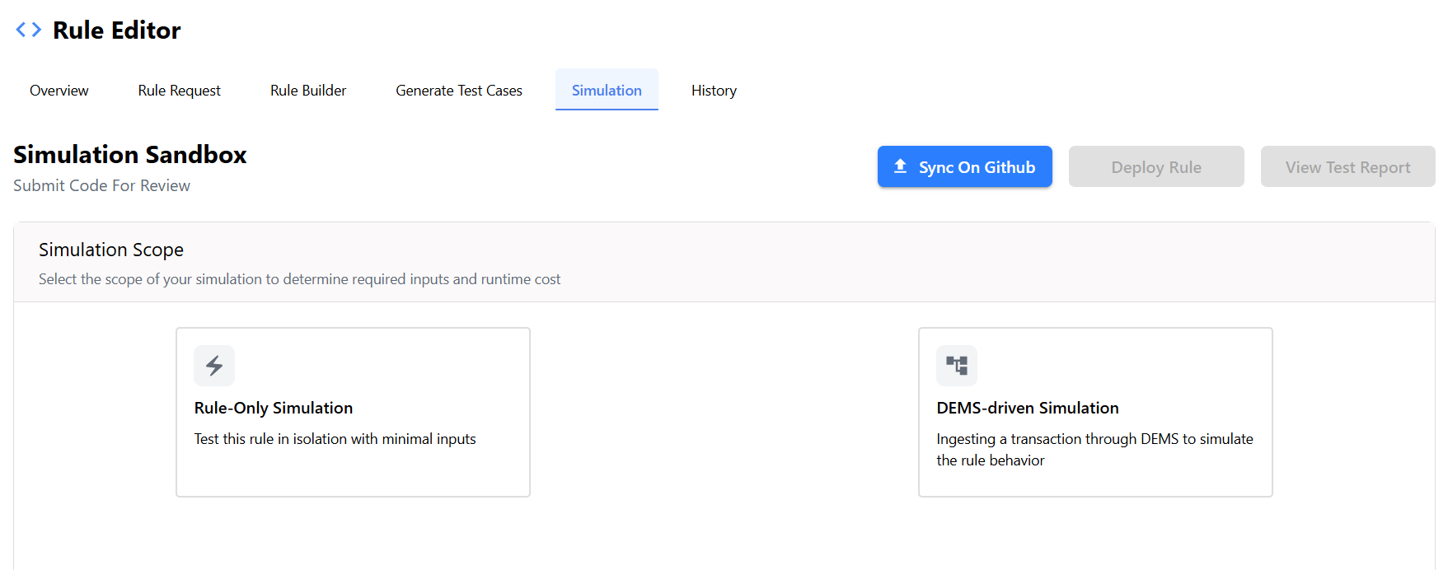Figure 20: The Sync to GitHub and Deploy Rule buttons in the Simulation tab.
Once deployment succeeds, your rule is live in the environment and ready to test. Choose your simulation mode and run it.
Always sync and deploy before simulating. This ensures you’re always testing your most recent changes — not a stale version from a previous session.

Reading Your Test Report
After you sync to GitHub, TRS generates a Test Report — your definitive record of how your rule performed against the test cases. Makers use it to confirm everything is working before submitting; Checkers use it as evidence during review. Here’s what the report covers:
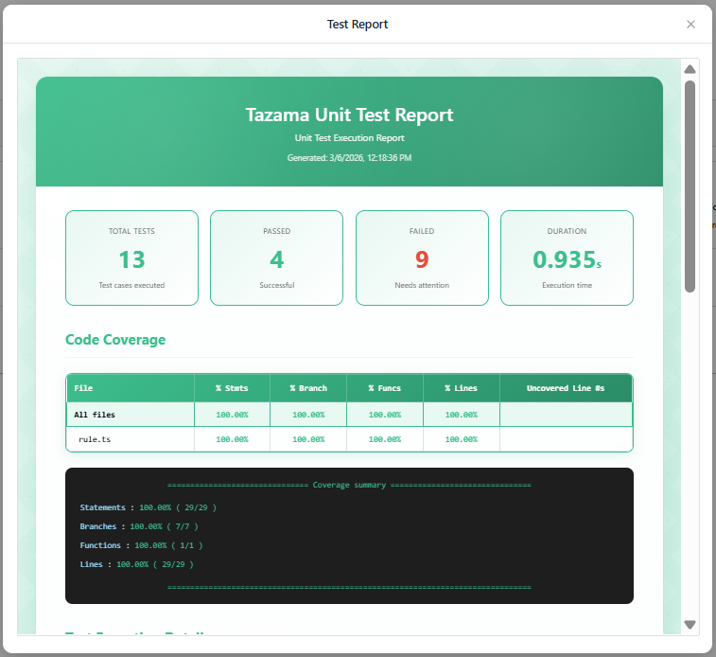
Figure 21: The Test Report — Execution Summary at the top showing total tests, passed, failed, and duration.
The report includes the following key sections:
- Test Execution Summary
This section provides a high-level overview of the test execution results, including:
- Total Tests – The total number of test cases executed.
- Passed – The number of tests that completed successfully.
- Failed – The number of tests that did not meet the expected outcome.
- Duration – The total time taken to execute the test suite.
This is the first thing you check — if anything failed, you’ll see it here immediately.
- Code Coverage
The code coverage section measures how thoroughly the rule logic has been exercised by the test cases. It reports coverage across several metrics:
- Statements – Percentage of executable statements covered by tests.
- Branches – Coverage of conditional branches such as if/else logic.
- Functions – Percentage of functions invoked during testing.
- Lines – Overall line-by-line code coverage.
Low coverage is a signal to add more test scenarios before submitting for review.
- Coverage Summary
A detailed textual summary of coverage statistics is also displayed, including counts of executed statements, branches, functions, and lines. This provides deeper insight into how thoroughly the rule code was exercised.

- Test Execution Details
This section lists each individual test case executed, along with:
- The test scenario description
- The expected rule outcome
- The execution status (pass/fail)
- The execution time for each test.
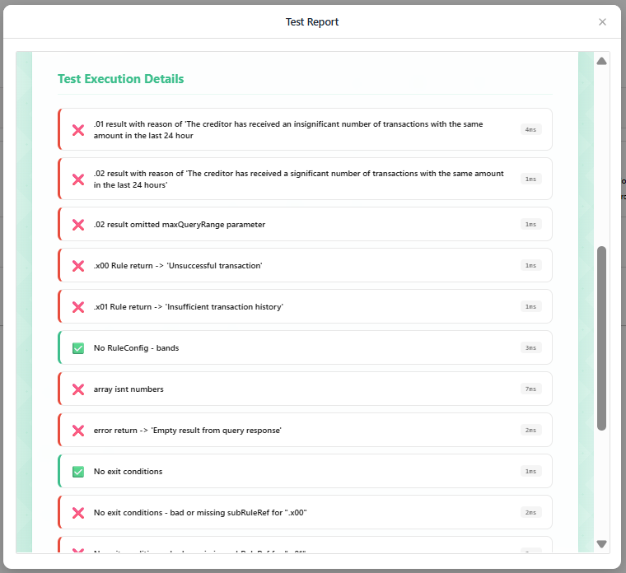
Figure 22: The Test Execution Details section — pass/fail status, expected outcomes, and execution time per test case.
- Test Suite Summary
At the end of the report, a consolidated summary of the entire test suite is provided, including:
- Total test suites executed
- Total tests passed
- Snapshot information (if applicable)
- Overall execution time

Testing in Isolation: Rule-Only Mode
In the Rule-Only Simulation mode, users can interact with the Rule Request Payload by editing values directly in the provided input fields. This allows users to customize specific fields to simulate different scenarios and validate how the rule behaves under various conditions. The fields can be easily modified to test specific logic, such as adjusting amounts or transaction types, while keeping the simulation isolated from other system dependencies.
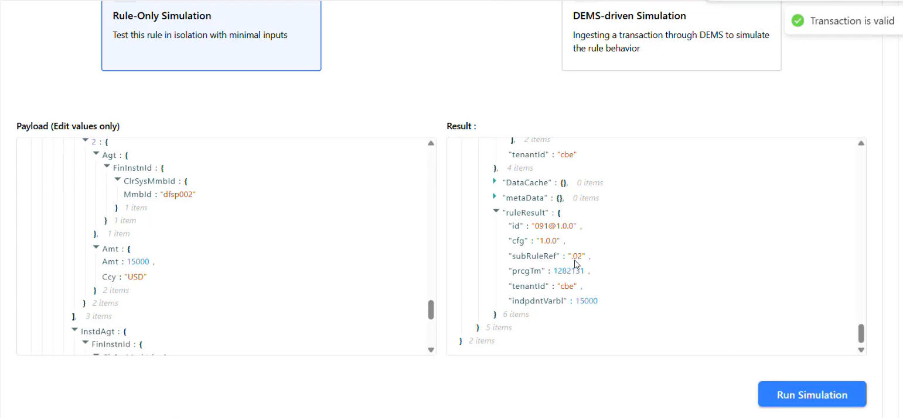
Figure 23: The Rule-Only Simulation screen: editable Rule Request Payload on the left, Result window on the right.
When you’re happy with the payload, click Run Simulation. The result appears in the adjacent Result window, showing exactly how your rule processed the input and what it returned.
Use this mode for fast, focused testing of individual scenarios. Once you’re satisfied the logic holds up in isolation, move on to DEMS-Driven mode for a full end-to-end check.

Testing End-to-End: DEMS-Driven Mode
The Dynamic Event Monitoring Service (DEMS) is the transaction ingestion layer of the Tazama platform. It dynamically accepts ISO 20022 messages, validates them, and routes them through the Tazama processing pipeline — from the Event Director to the Rule and Typology processors — where they are evaluated for financial crime indicators. DEMS is the entry point for all live and simulated transaction traffic within the ecosystem.
In the DEMS-driven Simulation mode, the user triggers the simulation by submitting a transaction through DEMS. The message is ingested and processed through the full pipeline as it would be in a production environment — passing through the Event Director and onward to the Rule and Typology processors. This allows the Maker to observe how the rule behaves in the context of an actual end-to-end transaction flow, rather than in isolation.
This mode is particularly useful for:
- Validating that the rule integrates correctly with the broader Tazama processing chain.
- Testing rule behaviour against realistic ISO 20022 message structures and payloads.
- Identifying edge cases that may not surface when testing in Rule-Only mode.
- Confirming correct rule application across the event processing chain before submitting for approval.
The resulting output is displayed once the transaction has been processed, showing how the rule evaluated the message and what outcome it produced.

Sending Your Rule for Approval
Once you’re satisfied that your rule is solid — the logic is correct, your test cases pass, and your simulations give you the results you expected — it’s time to hand it over. This section covers what happens when the Maker submits a rule for review, and what to expect next.

Are You Ready to Submit?
Before you click Send for Approval, take a moment to run through this checklist. Once the rule is submitted, you won’t be able to make any changes unless the Checker sends it back.
- Rule logic is complete. All nodes on the canvas are connected, configured, and generate clean TypeScript without errors.
- Test cases cover your key scenarios. At minimum, your test cases should cover the main exit paths and expected error conditions for the rule.
- Simulations have been run. You’ve run at least one simulation - Rule-Only or DEMS-Driven - and the results look as expected.
- Test Report passes. Your Test Report shows all test cases passing with adequate coverage. Low coverage or failing tests should be resolved before submitting.
- Rule metadata is accurate. The Rule Name, Version, Type, and Description in Rule Overview accurately describe what the rule does.

How to Submit
When you’re ready, navigate to the rule on your Rule Dashboard and click Send for Approval. The rule status immediately transitions from In Progress to Under Review, and the rule is routed to the Checker queue.
After you click Send for Approval, a confirmation dialog will appear asking you to verify the submission. This is your last prompt before the rule is locked for editing — click Confirm to complete it.
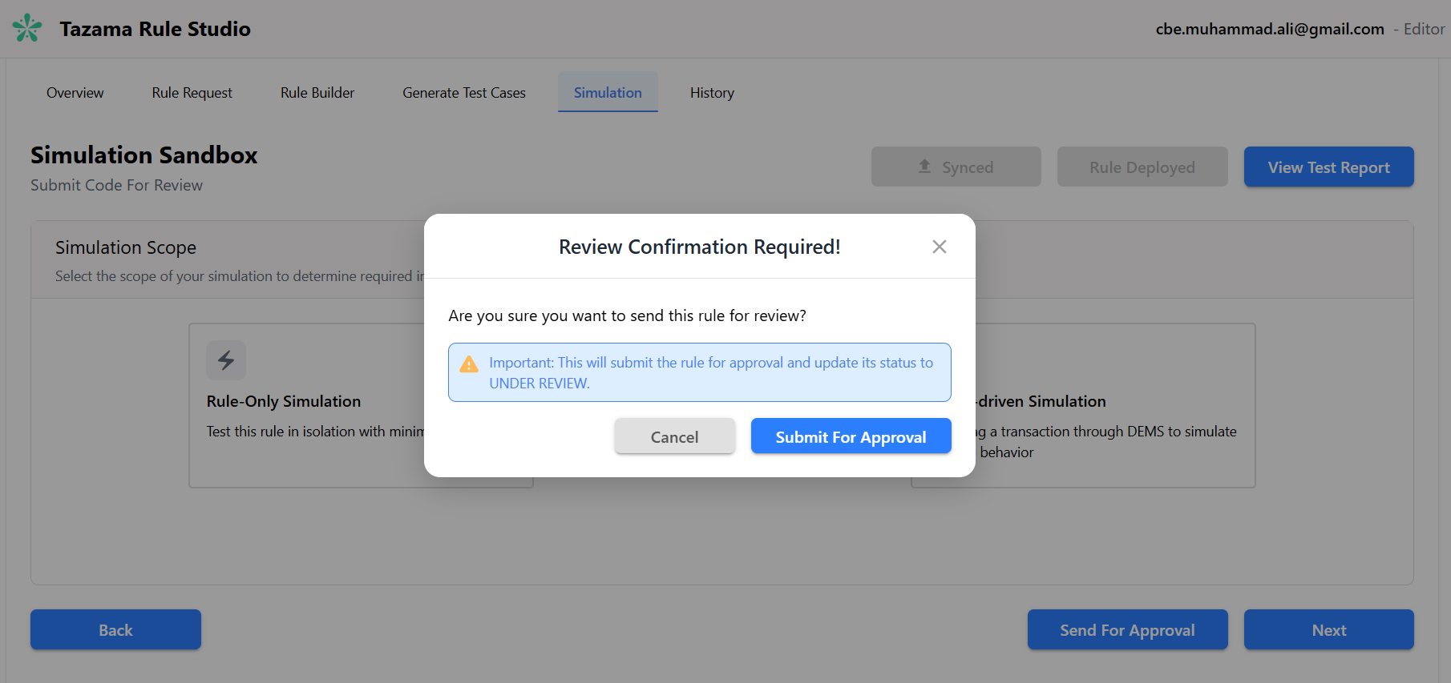Figure 24: The confirmation dialog — the Maker's last prompt before the rule is locked for editing.

What Happens After You Submit
Once the rule is Under Review, the following restrictions apply:
- You can no longer edit the rule logic, configuration, or metadata.
- The rule becomes visible to Checkers in their queue on the Rule Dashboard.
- You can still view the rule in read-only mode to track its status.
From here, the ball is in the Checker’s court. You’ll know the outcome when the rule status changes to one of the following:
- Approved — the Checker was satisfied and signed off. The rule moves to the Deployer.
- Rejected — the Checker found issues and sent it back. You’ll receive comments explaining what needs to change, and the rule returns to In Progress so you can make corrections and resubmit.

If Your Rule Gets Rejected
A rejection isn’t the end — it’s feedback. When a Checker rejects a rule, they can optionally include comments explaining what needs to change. If comments are provided, you’ll find them in the rule’s detail view on the Dashboard — they’re your clearest guide to what to address. Once you’ve reviewed the feedback, the rule returns to In Progress and you can edit it again. Make your corrections, re-run simulations to confirm the fix, and resubmit when you’re ready.

Reviewing a Rule as a Checker
As a Checker, your role is to be the quality gate between rule development and production. You’re not expected to rebuild the rule — you’re here to verify that it’s correct, complete, and safe to deploy. This section walks you through how to find rules awaiting review, what to assess, and how to reach your decision.

Finding Rules to Review
When a Maker submits a rule for approval, it appears in your Rule Dashboard with a status of Under Review. Use the Status filter on the Dashboard to quickly surface all rules waiting for your attention.
Click on a rule to open it. As a Checker, you have access to the same screens the Maker used - the Rule Builder, Test Case Builder, and Simulation tab - but everything opens in read-only mode. You can inspect every node, every connection, and every piece of generated code, but you cannot make any changes.
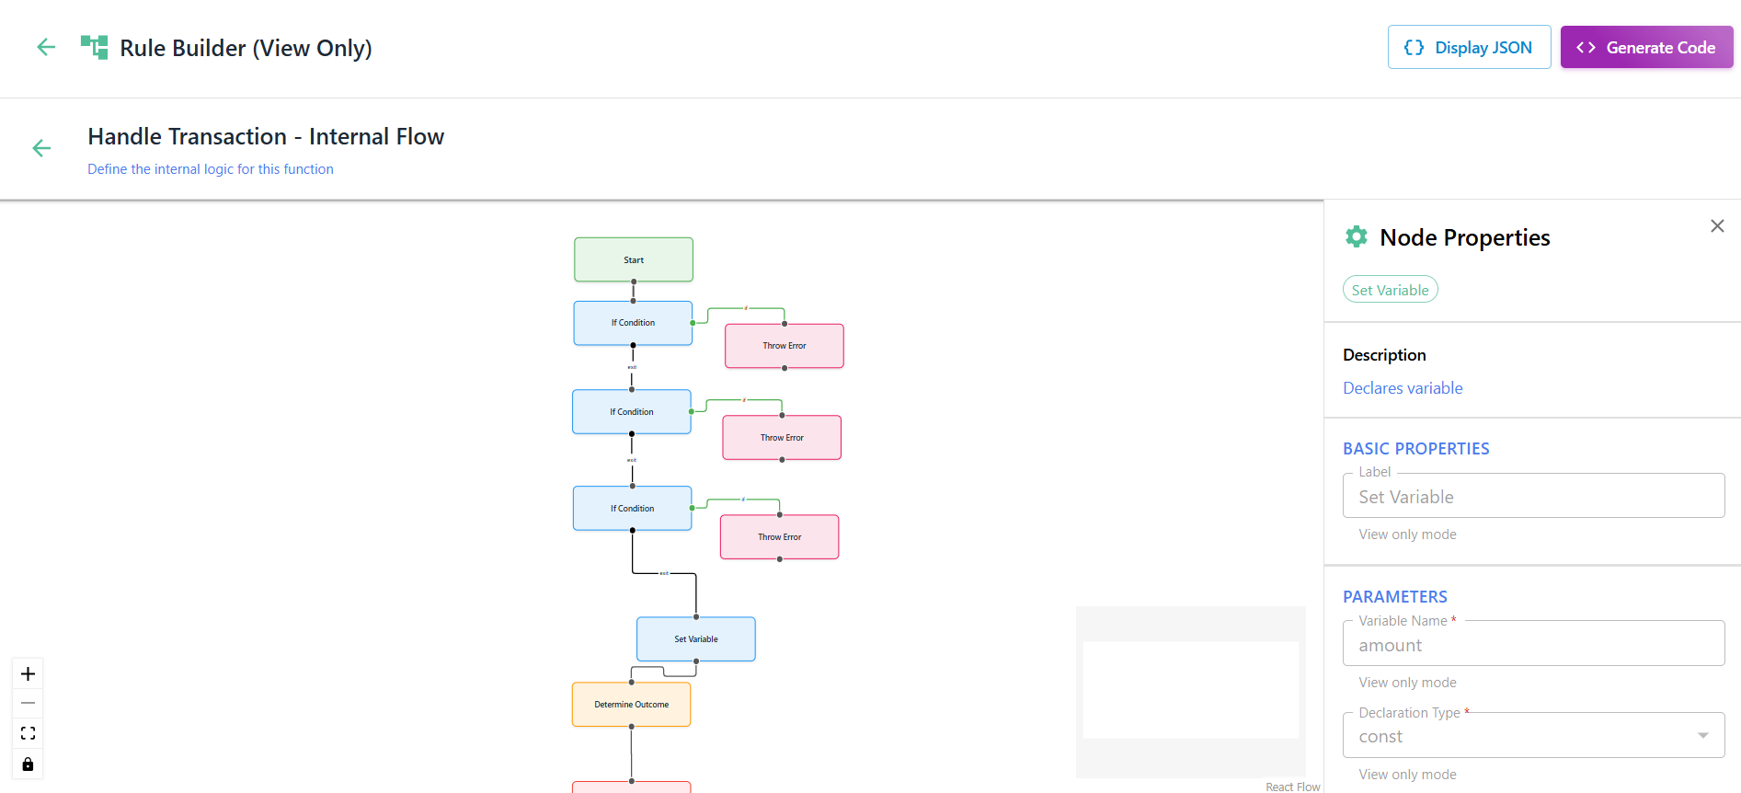Figure 25: A rule open in read-only mode as seen by the Checker — all edit controls are disabled.

What to Review
A thorough review covers three areas:

Rule Logic and Configuration
Open the Rule Builder to inspect the canvas. You’re looking for:
- Does the node structure make logical sense from Start to End?
- Are variables named clearly and used consistently?
- Do conditional branches cover all expected outcomes, including edge cases?
- Does the generated TypeScript match what you’d expect from the visual flow?
- Are any custom code nodes doing something unexpected or potentially unsafe?
Use the Generate Code view to read the compiled TypeScript directly. This is often the clearest way to verify that the rule does exactly what it’s described as doing.

Test Cases and Coverage
Open the Test Case Builder to review the test structure. Ask yourself:
- Do the test cases cover the rule’s key exit conditions?
- Are there tests for error scenarios, not just the happy path?
- Does the Test Report show all cases passing?
- Is code coverage at an acceptable level for your organisation’s standards?
If coverage is thin or test cases don’t adequately stress the rule’s logic, this is a valid reason to reject and ask the Maker to strengthen their test suite.

Simulation Results
Navigate to the Simulation tab - the same tab the Maker used - and run whichever mode suits your review:
- Rule-Only Simulation — useful for testing specific edge cases or boundary conditions you want to probe yourself.
- DEMS-Driven Simulation — useful for validating that the rule integrates correctly with the broader processing pipeline and behaves as expected against real ISO 20022 message structures.
Check the Simulation Logs to review both the Maker’s prior runs and any simulations you run yourself.

Aligning with Fraud Strategy
Beyond technical correctness, your review should assess whether the rule aligns with your organization’s fraud strategy and risk appetite. Consider:
- Does the rule target the intended fraud typology or AML scenario?
- Are the thresholds and conditions calibrated appropriately — not so broad they generate false positives, not so narrow they miss genuine risk?
- Does the rule description accurately reflect what it actually does?
- Are there unintended side effects that could affect other rules or typologies in the network map?

Making Your Decision
Once your review is complete, you have two options:
- Approve — you’re satisfied the rule is correct, well-tested, and strategically sound. Click Approve and the rule transitions to Approved status, becoming available to the Deployer.
- Reject — you’ve identified issues that need addressing before the rule is production-ready. You can optionally include comments to explain what needs to change — the Maker will be notified to make corrections and resubmit.

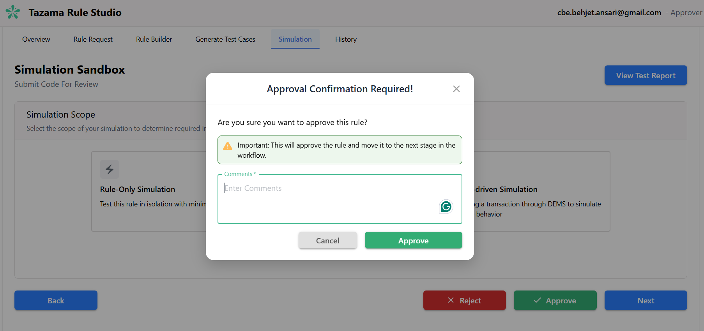Figure 26: The Approve and Reject action buttons available to the Checker on a rule in Under Review status.
If you do include comments, write them clearly and specifically. Even a brief note — “the threshold on this node should be 500, not 5000” — is far more useful than “logic needs work.” Clear feedback speeds up the resubmission cycle for everyone.

Approving the Rule
When the Checker is satisfied with the rule, they approve it. This is a deliberate, consequential action — approval signals that the rule is correct, tested, and ready for production. Here’s what happens at this stage and what it means for everyone involved.

What Approval Does
Clicking Approve transitions the rule status from Under Review to Approved. The following immediately takes effect:
- The rule is locked. No further changes can be made to the rule logic, configuration, or metadata by anyone — Maker, Checker, or otherwise.
- The rule becomes visible to Deployers in the Approved state on the Rule Dashboard.
- The Maker is notified that their rule has been approved.

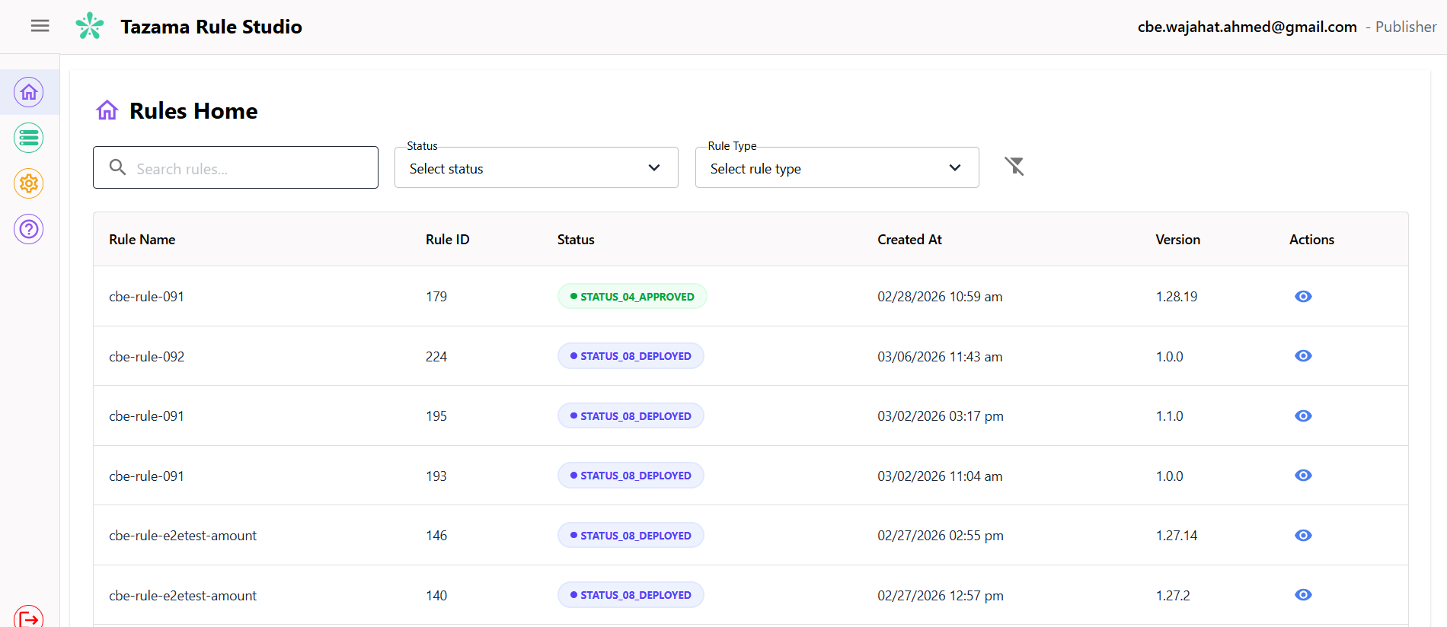Figure 27: The Rule Dashboard showing the rule in Approved status, now visible to the Deployer.

Deploying to Production
Deployment is the final step in the rule lifecycle. As a Deployer, you’re responsible for taking an approved rule and activating it in the production environment. This is the point of no return — once deployed, the rule is live and evaluating real transactions. This section walks you through what to check before deploying and exactly what happens when you do.

Finding Approved Rules
Log in to TRS and navigate to your Rule Dashboard. Filter by Approved status to see all rules that have cleared the Checker and are ready for deployment. Only rules in Approved status are available for deployment — you cannot deploy a rule that is In Progress, Under Review, On Hold, or Rejected.

Before You Deploy
Deployment is irreversible, so it’s worth taking a moment to verify a few things before you initiate it:
- Confirm the approval status. The rule must show Approved status. Do not deploy a rule that has been approved in error or where you have reason to believe the approval was premature — escalate through your governance process instead.
- Check the rule version. Make sure you’re deploying the correct version. If multiple versions of a rule exist, confirm which one has been approved and is intended for production.
- Verify the target environment. Confirm that the deployment is targeting the correct environment. Rules deployed in error to production can affect live transaction monitoring immediately.
- Check for downstream dependencies. If this rule is part of a typology that also has other rules pending deployment, coordinate with your team to deploy them together where possible, to avoid partial typology configurations in production.

How to Deploy
Once you’re satisfied the rule is ready, click Deploy on the rule in your Dashboard.
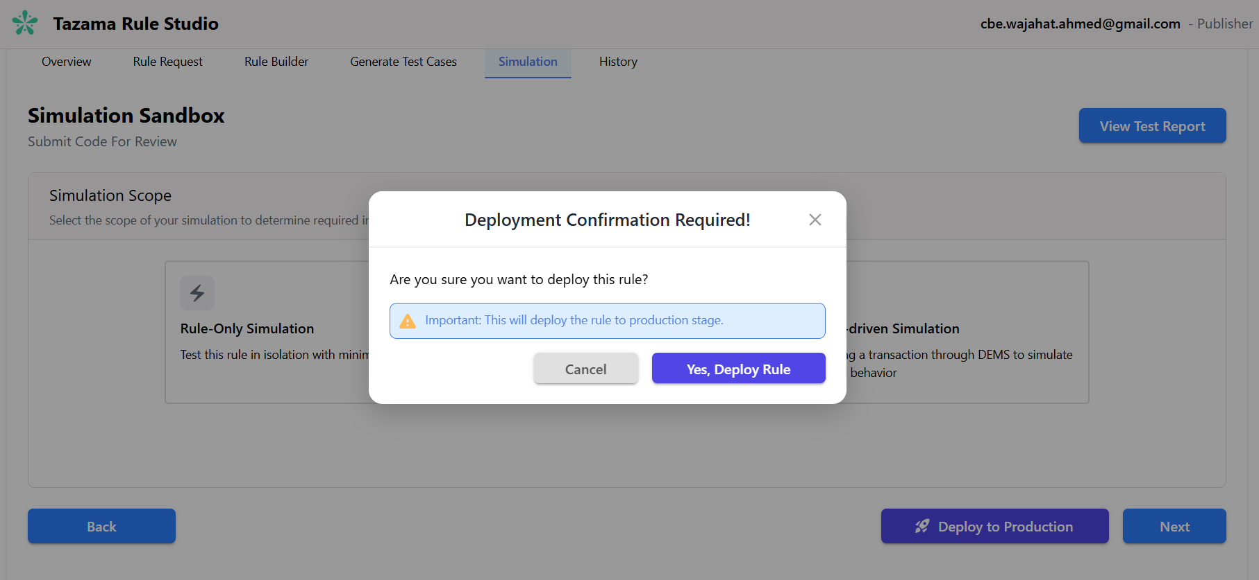
Figure 28: The confirmation message shown upon clicking Deploy to Production
The system will:
- Promote the rule configuration from the GitHub DEV branch to the PROD branch.
- Activate the rule in the production environment.
Once deployment succeeds, the rule status transitions from Approved to Deployed. The rule is now live and operational — it will evaluate every real transaction that matches its configured transaction type.

What If Something Goes Wrong?
If a rule behaves unexpectedly after deployment, do not attempt to modify it in TRS — Deployed rules are locked and cannot be edited. The recommended approach is:
- Clone the deployed rule. Use the Clone action on the Dashboard to create a new editable copy.
- Fix the issue on the clone. The Maker makes the necessary corrections and the clone goes through the full Maker–Checker–Deployer cycle.
- Deploy the corrected version. Once approved, the corrected clone is deployed, replacing or supplementing the original.
For urgent production issues, follow your organisation’s incident management process alongside the above steps.

Viewing Your Simulation Logs
The History tab is your simulation logbook. Every Rule-Only and DEMS-driven Simulation you've run is recorded here, so you can always look back at what you tested, when you ran it, and who ran it.
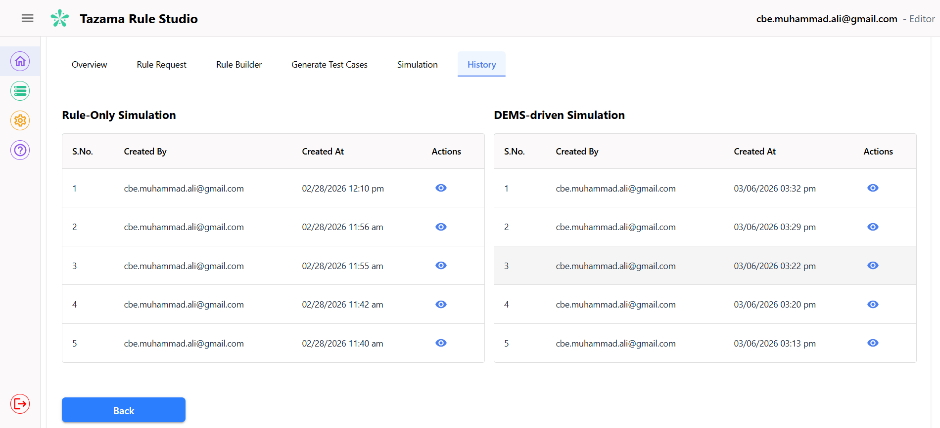Figure 29: The Simulation Logs / History tab showing Rule-Only and DEMS-driven simulation entries with Created By, Created At, and Actions columns.
In the Rule-Only Simulation section, each entry shows:
- S.No. – A unique serial number for the simulation.
- Created By – Who kicked off the simulation.
- Created At – The date and time it was run.
- Actions – Click the eye icon to view the full details of that simulation run.
The DEMS-driven Simulation section works the same way — once you've run an end-to-end simulation, its results will appear here. If you haven't run one yet, the section will show no records.
Use the History tab whenever you need to retrace your steps — whether you're tracking testing progress, comparing results across runs, or digging into a past execution to troubleshoot unexpected rule behavior.

Appendices

Closing Note
The Tazama Rule Studio is designed to bring rigor and structure to one of the most consequential activities in a financial crime monitoring program — the definition and deployment of detection rules. Every capability documented in this manual serves that purpose: ensuring that the rules which ultimately evaluate live transactions are correct, thoroughly tested, and subject to appropriate governance before they reach production.
The following principles are offered as guidance for all TRS users, regardless of role:
Invest in testing before submission. The Test Case Builder and Simulation environment exist precisely so that defects are identified in a controlled setting rather than in production. Adequate coverage of exit conditions, error scenarios, and edge cases is not optional — it is the standard expected of every rule submitted for review.
Treat the Rule Request screen as your foundation. Before constructing rule logic, a thorough review of the Rule Request payload — its field paths, cached variables, and network map structure — will prevent the majority of logic errors and reduce rework significantly.
Approach the review cycle constructively. A Checker's rejection is a quality control mechanism, not a failure. Rules that return through the review cycle with precise, actionable feedback are invariably stronger for it. Both Makers and Checkers should approach the process as a collaborative audit rather than an adversarial one.
Maintain discipline around post-deployment issues. Should a deployed rule behave unexpectedly in production, the correct response is to follow the Clone–Remediate–Redeploy process and, where necessary, to invoke your organisation's incident management procedures. Deployed rules are locked by design; this constraint exists to preserve the integrity of the audit trail.

Support and Escalation
For technical issues, access requests, or system configuration queries, contact your designated TRS system administrator or the Tazama platform support team.
For matters relating to fraud strategy, typology design, or regulatory alignment, consult your organization’s financial crime compliance function. Strategic input during the rule development phase is considerably more efficient than remediation following a Checker rejection or, worse, a post-deployment incident.

Glossary
- Rule — A configured set of conditions and logic that evaluates a transaction and produces an output (e.g. a score or flag) based on defined criteria.
- Rule Configuration — The template that defines the transaction schema, network context, and typology alignment a rule operates within.
- Rule Version — A numbered identifier that tracks iterations of a rule over its lifecycle.
- Rule Type — The classification of a rule's detection purpose: Fraud, AML, or Fraud & AML.
- Exit Condition — A defined outcome path within a rule (e.g. X00, X01) that the rule resolves to based on evaluated logic.
- Threshold — A numeric boundary used in rule conditions to determine whether a transaction characteristic triggers a particular outcome.
- Node — A discrete functional unit on the Rule Builder or Test Case canvas, representing a specific operation such as a variable declaration, condition, function call, or loop.
- Canvas — The visual workspace within the Rule Builder or Test Case Builder where nodes are placed and connected to form rule or test logic.
- Execution Flow — The order in which nodes are processed during rule evaluation, defined by the connections between them on the canvas.
- TypeScript — The programming language into which the Rule Builder canvas is compiled when Generate Code is invoked.
- Rule Request — The full structured data payload passed to a rule at evaluation time, comprising the Metadata, DataCache, Network Map, and Transaction object.
- Metadata — Envelope-level information accompanying a Rule Request, including tenant ID, timestamp, correlation ID, and transaction type.
- DataCache — A set of pre-resolved, frequently accessed identifiers (e.g. party IDs, settlement amount) cached by the platform before rule execution to avoid redundant lookups.
- Network Map — A configuration object that defines how a transaction is routed through the Tazama processing network, specifying which typologies evaluate the transaction and which rules each typology depends on.
- Transaction Payload — The full ISO 20022 message object within the Rule Request, containing all transaction fields available for rule logic.
- ISO 20022 — The international financial messaging standard used by the Tazama platform to structure transaction data (e.g. pain.001.001.11 for credit transfer initiations).
- Field Path — The dot-notation reference used to access a specific field within the Rule Request object hierarchy (e.g. PmtInf.Dbtr).
- DEMS (Dynamic Event Monitoring Service) — The transaction ingestion layer of the Tazama platform, responsible for accepting, validating, and routing ISO 20022 messages through the processing pipeline.
- Typology — A defined fraud or financial crime scenario made up of one or more rules. The Typology Processor aggregates rule outputs to produce a typology score.
- Typology Processor — The Tazama platform component that evaluates rule outputs and combines them into a typology-level assessment.
- Event Director — The Tazama component responsible for receiving ingested transactions from DEMS and routing them to the appropriate rule and typology processors.

